# Sample MCQS for all Programs

**Name: ....................................... Tracking / Application No. .....................................**

**CNIC No.: ................................ Candidate Signatures: ..........................................**

|  |
| --- |
| **Admission Test: PhD (XYZ Department) Fall 2022-23** |

**Instructions:**

Please choose the most correct option by filling the appropriate box.

Spoiled or overwritten selection has no credit.

1 x 100 = 100

Qualifying Marks: **70** Time Allowed: **120 Minutes**

**Question 1** For all real numbers *x*, 1 − (1 − (1 − *x*) − 1) *=*

B

C

D

* 1. − *x*

A

*x* − 1 *x*

* 1. − *x*

**Question 2** Which of the following comes at the end of the evolution of pre-Elizabethan phase of English drama?

Mysteries

A

Nun’s Priest’s Tale

Moralities

Miracles

**Question 3** Who was the first President of the Constituent Assembly of Pakistan?

B

C

D

Liaquat Ali Khan

A

Moulvi Tameez ud Din

Quaid e Azam

Sardar Abdur Rab Nishtar

**Question 4** Golding’s Lord of the Flies is a sort of

B

C

D

Angry Young Man

A

Wasteland

Hamlet

Robinson Crusoe

**Question 5** If *f* is a function of bounded variation on [*a*, *b*] and if ∃ a positive number *k* such that ∀*x* ∈ [*a*, *b*], then is also

B

C

D

of bounded variation on [*a*, *b*].

| *f* (*x*)| ≥ *k*

A

| *f* (*x*)| *= k*

B

| *f* (*x*)| ≥ *k*

C

None of these

D

**Question 6** In zoology the word zoo mean

Medicine

A

Earth

Plant

Animal

**Question 7** A container is filled with water at 4°C. The water will overflow if the temperature of water is

B

C

D

Increased or decreased

A

None of them

Increased

Decreased

**Question 8** Which of the following is not a non-metallic mineral

B

C

D

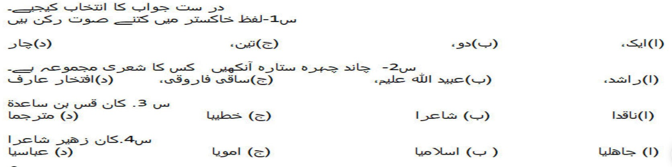

A Bauxite

B Mica

C Granite

D Silica