SCHEME OF STUDY
BS Applied Psychology (Session: 2021-2025)
SEMESTER – I
Course Code | Course Title | Credit Hours
ENG-321 | Functional English | 3(3-0)
ISL-321 | Islamic Studies | 2(2-0)
ISL-322 | Ethics (for Non-Muslims Only) | 2(2-0)
PSY-301 | Introduction to Psychology-I | 4(3-1)
MTH-321 | Algebra and Trigonometry | 3(3-0)
PSY-303 | Tolerance | 3(3-0)
SOC-307 | Introduction to Sociology | 3(3-0)
ISL-311 | Translation of the Holy Quran-I | 1(1-0)
19
SEMESTER – II
ENG-322 | English Comprehension & Composition | 3(3-0)
PST-321 | Pakistan Studies | 2(2-0)
PSY-302 | Introduction to Psychology-II | 4(3-1)
STA-321 | Introduction to Statistical Theory | 3(2-1)
CSI-321 | Introduction to Computer Application | 3(3-0)
15
SEMESTER – III
ENG-421 | Communication Skills | 3(3-0)
PSY-401 | History & Systems in Psychology | 3(3-0)
PSY-403 | Personality Psychology | 3(3-0)
PSY-405 | Social Psychology | 4(4-0)
EDU-503 | Foundation of Education | 3(3-0)
ISL-411 | Translation of the Holy Quran-II | 1(1-0)
17
SEMESTER – IV
ENG-422 | Technical Writing | 3(3-0)
PSY-402 | Developmental Psychology | 4(4-0)
PSY-404 | Cognitive & Affective Processes | 4(3-1)
PSY-406 | Behavioral Neurosciences | 4(4-0)
MPH-601 | Foundation of Public Health | 3(3-0)
18
SEMESTER – V
PSY-501 | Psychological Testing & Measurement-I | 3(3-0)
PSY-503 | Mental Health and Psychopathology-I | 3(3-0)
PSY-505 | Research Methodology-I | 3(3-0)
PSY-507 | Application of Statistics in Psychology | 3(2-1)
PSY-509 | Industrial/Organizational Psychology | 4(4-0)
ISL-511 | Translation of the Holy Quran-III | 1(1-0)
17
SEMESTER – VI
PSY-502 | Psychological Testing & Measurement-II | 3(2-1)
PSY-504 | Mental Health and Psychopathology-II | 3(3-0)
PSY-506 | Research Methodology-II | 3(2-1)
PSY-508 | Human Resource Management | 3(2-1)
PSY-510 | Health Psychology | 4(3-1)
16
SEMESTER – VII
PSY-601 | Clinical Psychology-I | 3(3-0)
PSY-603 | Counseling Psychology-I | 3(3-0)
PSY-605 | Cross-cultural Psychology | 4(4-0)
PSY-607 | Educational Psychology | 4(3-1)
ISL-611 | Translation of the Holy Quran-IV | 1(1-0)
Thesis (Synopsis Submission) OR any One Optional Subject
PSY-611 | Psychology of Emotions | 3(3-0)
PSY-613 | Trauma Psychology | 3(3-0)
PSY-615 | Consumer Behavior | 3(3-0)
PSY-617 | Media Psychology | 3(3-0)
18
SEMESTER – VIII
PSY-602 | Clinical Psychology-II | 4(3-1)
PSY-604 | Counseling Psychology-II | 3(2-1)
PSY-606 | Positive Psychology | 3(3-0)
PSY-608 | Forensic Psychology | 3(3-0)
PSY-632 | Internship | 2(0-2)
PSY-630 | Thesis (Final Draft and Oral Defense) OR any One Optional Subject | 6(0-6)
PSY-610 | Muslim Psychology | 3(3-0)
PSY-612 | Sports Psychology | 3(3-0)
PSY-614 | Gender Issues in Psychology | 3(3-0)
PSY-616 | Environmental Psychology | 3(3-0)
18

COURSE OUTLINES

Semester - I

Code: ENG-321 | FUNCTIONAL ENGLISH | Credit Hours: 3(3-0)

Part 1: Grammar in context
- Basics of Grammar
- Parts of speech and use of articles
- Sentence structure, active and passive voice
- Practice in unified sentence(synthesis)
- Analysis of phrase, clause and sentence structure
- Transformation, Inversion of sentences
- Analysis of Complex sentences
- Subject, Predicate, Complements, direct & indirect objects
- Direct and Indirect speech

Part 2: Functional English in use

Making introductions
- Making effective self and peer introductions
- Taking useful introductory notes
Expressing requests and enquiries

- Forming appropriate requests and enquiries
- Responding to enquiries
- Requests versus commands
Greetings

- Greeting friends and family on different occasions and for different reasons
- Responding to a positive event
- Using formal greeting expressions appropriately
Gratitude

- Using formal and informal expressions of gratitude appropriately
Invitations

- Demonstrating the use of formal and informal expressions of invitation
- Developing verbal and written skills for invitations
- Responding to invitation requests by accepting or declining
Regrets

- Expressing regrets orally and in writing appropriately
- Saying sorry and accepting apologies
Following and giving directions
- Following directions from a map
- Giving directions to a location in oral and narrative and imaginative texts by composing stories and sharing them in writtenand oral form.
Sharing narratives
- Reading short stories
- Reading excerpts, comic strips, interviews, and other common texts
Sharing unique experiences

- Summarizing and narrating true stories
- Solving word puzzles to develop language awareness
- Reading short stories and completing exercises to test comprehension
- Converting an event into a short story
- Using pictures as stimuli for narrative creation
Key Books:
Eastwood, J. (2005). Oxford Practice Grammar. UK: Oxford.
Wren & Martin. (2007). High School, English Grammar & Composition. New Delhi: S Chand & Company Limited.
Thomson &Martinent. (1992). A practical English Grammar. UK: Oxford.
Swan, M. (2005). Practical English Usage. UK: Oxford University Press.
Shah, S. (2006). Exploring the world of English. Lahore: IlmiKitabKhana.

References:
Hewings, M. (2008). Advanced Grammar in Use. New Delhi: CUP. (For classroom teaching and practice)
Ur.P. (2008). Grammar Practice Activities: A Practical Guide for Teachers. Cambridge: CUP. (Topics for Assignments may be chosen from this Practice book)
Quirk, R.et al. (1983). Comprehensive Grammar of the English Language. London: Longman.
Leech, G., and Jan, S. (1998). A Communicative Grammar of English. London: Longman.
Allama Iqbal Open University, Compulsory English 1 (Code 1423) (Islamabad: AIOU Press). BBC. (2013) Learning English. http://www.bbc.co.uk/worldservice/learningenglish/
British Council. Learn English. http://learnenglish.britishcouncil.org/en/
British Council and BBC. Learn English. http://www.teachingenglish.org.uk/
Grammar software free download: 3D Grammar English. http://freesoftwarepc.biz/educational-software/ download-free-software-3d-grammar-English-portable

Code: ISL-321 | ISLAMIC STUDIES | Credit Hours: 02(2-0)
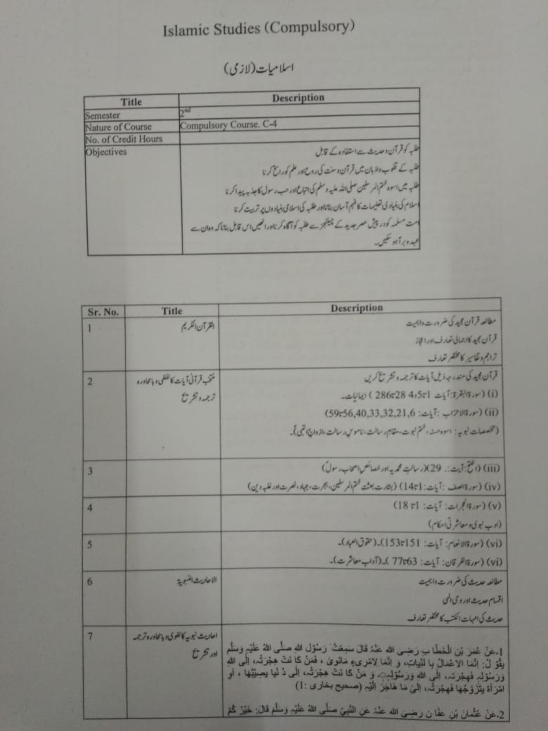
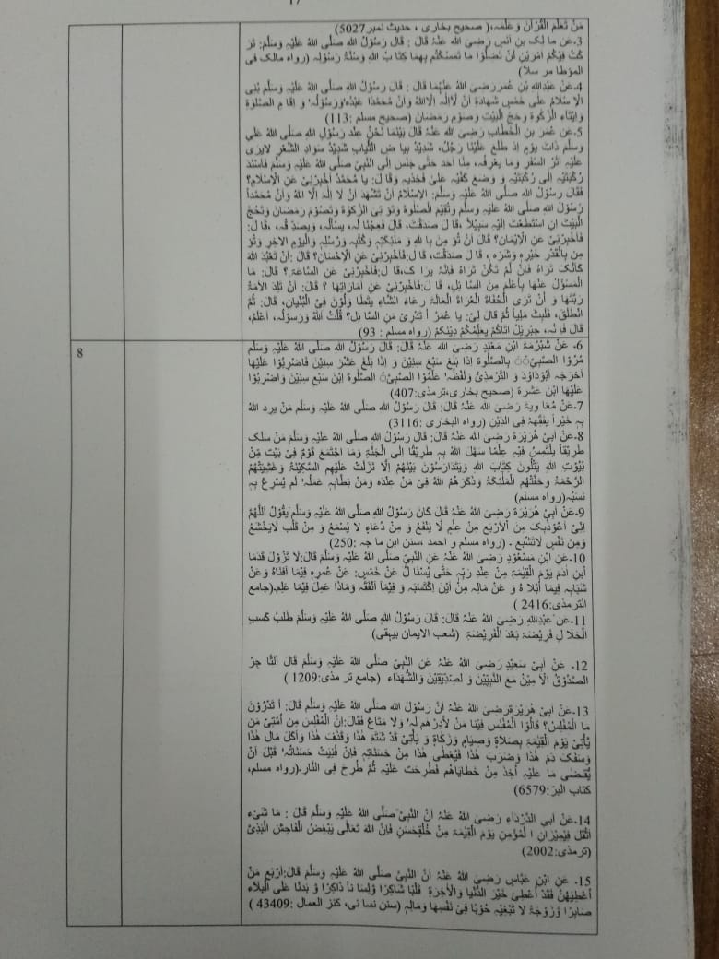

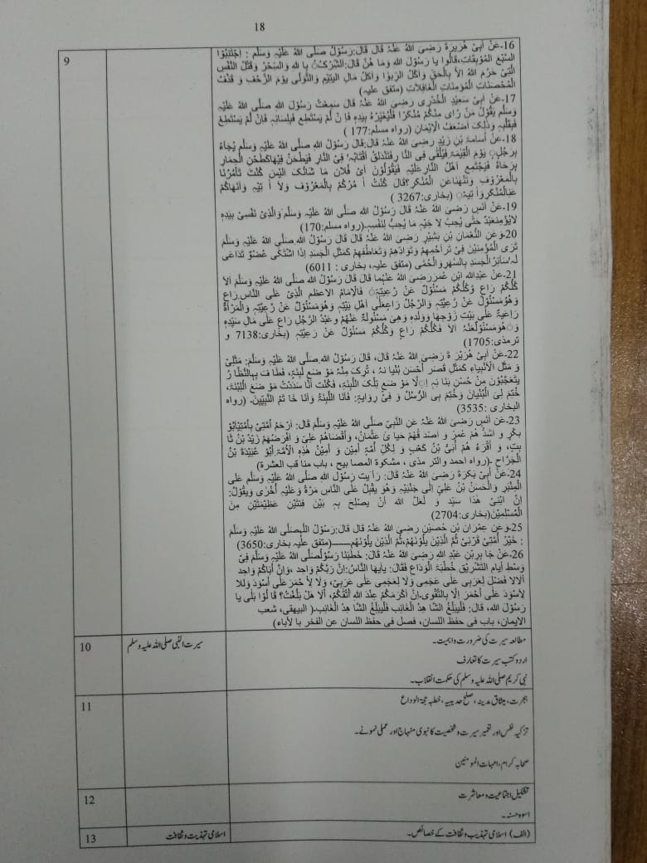

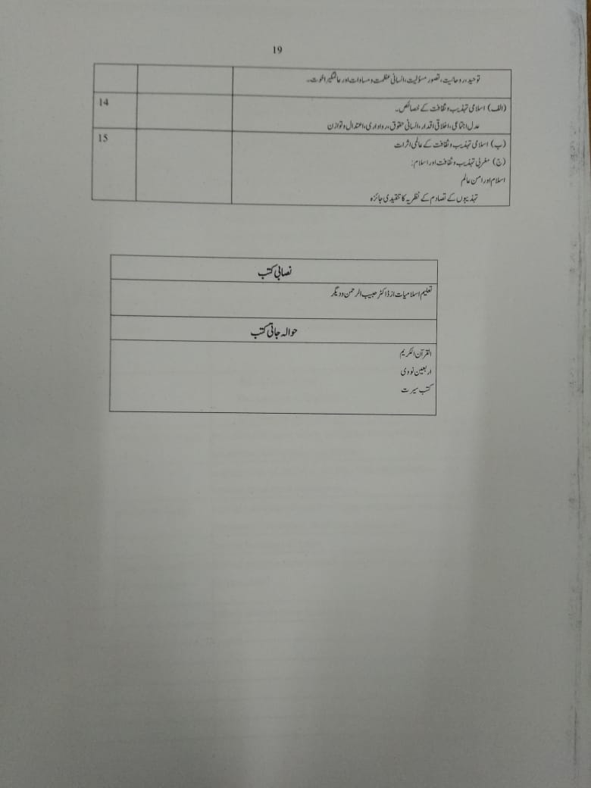

Code: ISL-322 | ETHICS (FOR NON-MUSLIMS ONLY) | Credit Hours: 02(2-0)
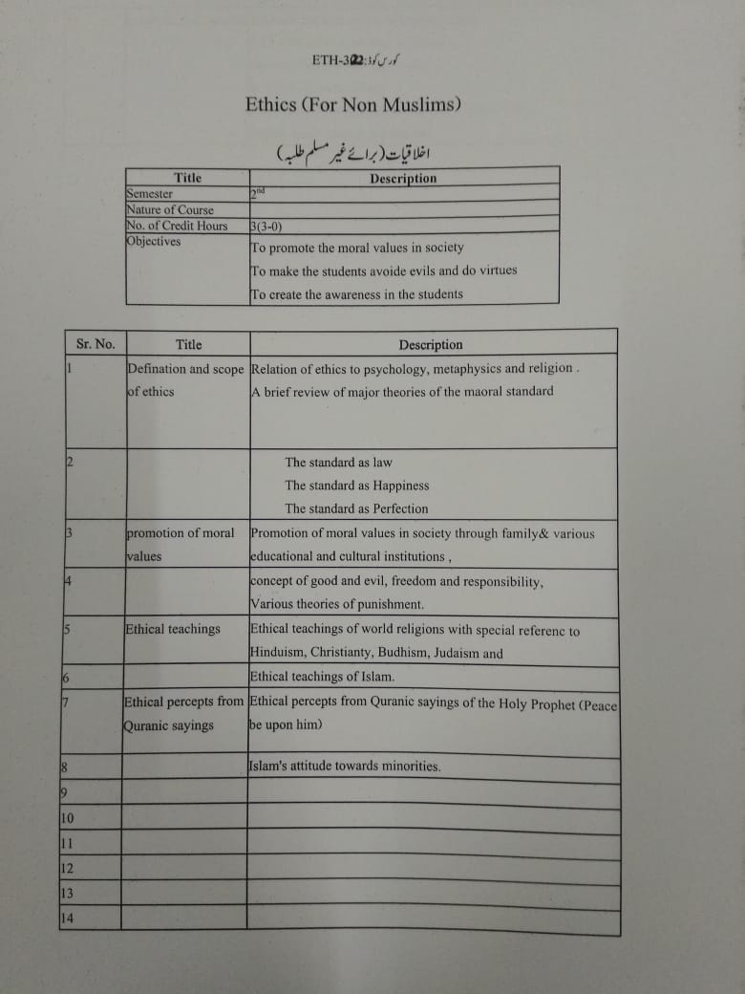

Code: PSY-301 | INTRODUCTION TO PSYCHOLOGY – I | Credit Hours: 04(3-1)

OBJECTIVES
- To describe psychology with major areas in the field, and identify the parameters of this discipline.
- To distinguish between the major perspectives on human thought and behavior.
- To appreciate the variety of ways psychological data are gathered and evaluated.
- To explore the ways that psychological theories are used to describe, understand, predict and control or modify behavior

COURSE CONTENT
Introduction to Psychology
- Nature and Application of Psychology with special reference to Pakistan.
- Historical Background and Schools of Psychology

Methods of psychology
- Observation
- Case History Method
- Experimental Method
- Correlational and comparative studies
- Longitudinal studies

Biological Basis of Behavior
- Neuron: Structure and Functions
- Central Nervous system & Peripheral Nervous system
- Endocrine Glands

Sensation, Perception and Attention
- Characteristics and Major Functions of Different Sensations
- Vision: Structure and function of the Eye.
- Audition: Structure and function of the Ear.

Perception
- Nature of Perception
- Factors of Perception: Subjective, Objective, and Social.
- Kinds of Perception.
- Spatial Perception (Perception of Depth and Distance)
- Temporal Perception; Auditory Perception.

Attention
- Factors, Subjective and Objective
- Span of Attention.

Practicum:
Following experiments shall be performed by the students:
- Blind Spot
- Attention Span
- Perceptual Grouping
- Size Constancy
- Depth perception
BOOKS:

Recommended

Myers, D.G (2013). Introduction t to psychology. Open University Press

Hayes, N (2010). Foundation of psychology (8th Ed.). Thomson Learning.

References

Atkinson R. C. & Smith E. E. (2000). Introduction to psychology (13th Ed.). USA: Harcourt
Brace College Publishers.

Fernald, L.D, & Fernald, P. S. (2005). Introduction to psychology. USA: WMC Brown
Publishers

Code: MTH-321 | ALGEBRA AND TRIGNMETRY | Credit Hours: 03(3-0)

OBJECTIVES
- To give the basic knowledge of algebra and trigonometry to the students.
- To enable the students understand the use of the essential tools of basic mathematics
- To educate the learners to apply the concepts and the techniques in their respective disciplines.

COURSE CONTENTS
Preliminaries: Real-number system, complex numbers, introduction to sets, set
operations, functions, types of functions. Matrices: Introduction to matrices, types, matrix
inverse, determinants, system of linear equations, Cramer’s rule. Quadratic Equations:
Solution of quadratic equations, qualitative analysis of roots of a quadratic equations,
equations reducible to quadratic equations, cube roots of unity, relation between roots and
coefficients of quadratic equations. Sequences and Series: Arithmetic progression, geometric
progression, harmonic progression. Binomial Theorem: Introduction to mathematical
induction, binomial theorem with rational and irrational indices. Trigonometry: Fundamentals
of trigonometry, trigonometric identities.

RECOMMENDED BOOKS:
1. Dolciani MP, Wooton W, Beckenback EF, Sharron S, Algebra 2 and Trigonometry, 1978,
Houghton & Mifflin,
2. Boston (suggested text) Kaufmann JE, College Algebra and Trigonometry, 1987,
PWSKent Company, Boston
3. Swokowski EW, Fundamentals of Algebra and Trigonometry (6th edition), 1986, PWSKent
Company, Boston.

Code: PSY-303 | TOLERANCE | Credit Hours: 03(3-0)

Objectives
- To enable the students to learn tolerance .
- To enable students to become tolerant person.
- To explore different strategies and dynamics to counter the intolerance in society.
- To educate psychological, cultural, social and religious aspects of tolerance
- To enable the students to promote tolerance using psychological interventions.
COURSE CONTENTS

Introduction
- Definition of tolerance
- Types of tolerance
- Basic concepts in different cultures
- Islamic views of tolerance
- Racial and cultural background in intolerance
Socialization and Tolerance
- Tolerance in groups, community and society
- Tolerance as a moral virtue
- Intolerance and violence
- Social components as modifiers of tolerance
- Indicators of intolerance

Aspects of Tolerance
- Developmental and physical aspect in tolerance
- Social aspects of tolerance and intolerance
- Psychological and spiritual aspects of intolerance
- Personality patterns, genes and heredity aspects

Behavioral components of tolerance
- Acceptance
- Understanding
- Altruistic behaviors
- Empathy and morality

Dynamics of Intolerance
- Racial, sexual discrimination
- Apartheid and segregation
- Aggressive nationalism
- Religious fanaticism and political oppression

Pathology of Intolerant Behaviour
- Pathology of Intolerant behavior
- Social learning theory and tolerance
- Clinical issues regarding intolerance

Interventions to Promote Tolerance
- Hopeful role of psychological interventions in developing tolerance.
- Cognitive behavior therapy
- Rational Emotion Behavior Therapy
- Client Centered Therapy
- Group Therapy
- Why should we educate our society the tolerance

CORE READING
- Agius, E & Ambrosewicz, J. (2003) Towards a Culture of Tolerance and Pace .

RECOMMENDED READING

Waraich,A (2018,april 13) Tolerance – Its Importance in Social Life .Retrieved from
- http://www.alhakam.org/tolerance-its-importance-in-social-life/
- Hogan, R., & Smither, R. (2001). Personality: Theories and applications. Westview Press.
- DSM
- Dell, P. F., & O'Neil, J. A. (Eds.). (2010). Dissociation and the dissociative disorders: DSM-V and beyond. Routledge.
- The Highly Sensitive Person
- Jaeger, B. (2004). Making work for the highly sensitive person. McGraw-Hill.
- Federn, P. (1932). The Reality of the Death Instinct, Especially in Melancholia: Remarks on Freud's Book:“Civilization and its Discontents”. Psychoanalytic Review, 19(2), 129-151.

Code: SOC-307 | INTRODUCTION TO SOCIOLOGY | Credit Hours: 03(3-0)

OBJECTIVE:
The course is designed to introduce the students with sociological concepts and the discipline. The focus of the course shall be on significant concepts like social systems and structures, socio-economic changes and social processes. The course will provide due foundation for further studies in the field of sociology.

COURSE OUTLINE

Introduction
- Definition, Scope, and Subject Matter
- Sociology as a Science
- Historical back ground of Sociology
Basic Concepts
- Group, Community, Society
- Associations
  - Non-Voluntary
  - Voluntary
Organization
  - Informal
  - Formal
- Social Interaction
- Levels of Social Interaction
- Process of Social Interaction
- Cooperation
- Competition
- Conflict
- Accommodation
- Acculturation and diffusion
- Assimilation
- Amalgamation
Social Groups
- Definition & Functions
- Types of social groups
  - In and out groups
  - Primary and Secondary group
  - Reference groups
  - Informal and Formal groups
  - Pressure groups
Culture
- Definition, aspects and characteristics of Culture
  - Material and non material culture
  - Ideal and real culture
- Elements of culture
  - Beliefs
  - Values
  - Norms and social sanctions
- Organizations of culture
  - Traits
  - Complexes
  - Patterns
  - Ethos
  - Theme
- Other related concepts
  - Cultural Relativism
  - Sub Cultures
  - Ethnocentrism and Xenocentrism
  - Cultural lag
- Socialization & Personality
  - Personality, Factors in Personality Formation
  - Socialization, Agencies of Socialization
  - Role & Status
- Deviance and Social Control
  - Deviance and its types
  - Social control and its need
  - Forms of Social control
  - Methods & Agencies of Social control
- Collective Behavior
  - Collective behavior, its types
  - Crowd behavior
  - Public opinion
  - Propaganda
  - Social movements
  - Leadership

RECOMMENDED BOOKS:
- Anderson, Margaret and Howard F. Taylor. 2001. Sociology the Essentials. Australia: Wadsworth.
- Brown, Ken 2004. Sociology. UK: Polity Press
- Gidden, Anthony 2002. Introduction to Sociology. UK: Polity Press.
- Macionis, John J. 2006. 10th Edition Sociology New Jersey: Prentice-Hall
- Tischler, Henry L. 2002. Introduction to Sociology 7th ed. New York: The Harcourt Press.
- Frank N Magill. 2003. International Encyclopedia of Sociology. U.S.A: Fitzroy Dearborn Publishers
- Macionis, John J. 2005. Sociology 10th ed. South Asia: Pearson Education
- Kerbo, Harold R. 1989. Sociology: Social Structure and Social Conflict. New York: Macmillan Publishing Company.
- Koening Samuel. 1957. Sociology: An Introduction to the Science of Society. New York: Barnes and Nobel..
- Lee, Alfred Mclung and Lee, Elizabeth Briant 1961. Marriage and The family.New York: Barnes and Noble, Inc.
- Leslie, Gerald et al. 1973. Order and Change: Introductory SociologyToronto: OxfordUniversity Press.
- Lenski, Gevbard and Lenski, Jeam. 1982. Human Societies. 4th edition New York: McGraw-Hill Book Company.
- James M. Henslin. 2004. Sociology: A Down to Earth Approach. Toronto: Allen and Bacon.

Code: ISL-311 | TRANSLATION OF THE HOLY QURAN-I | Credit Hours: 01(1-0)
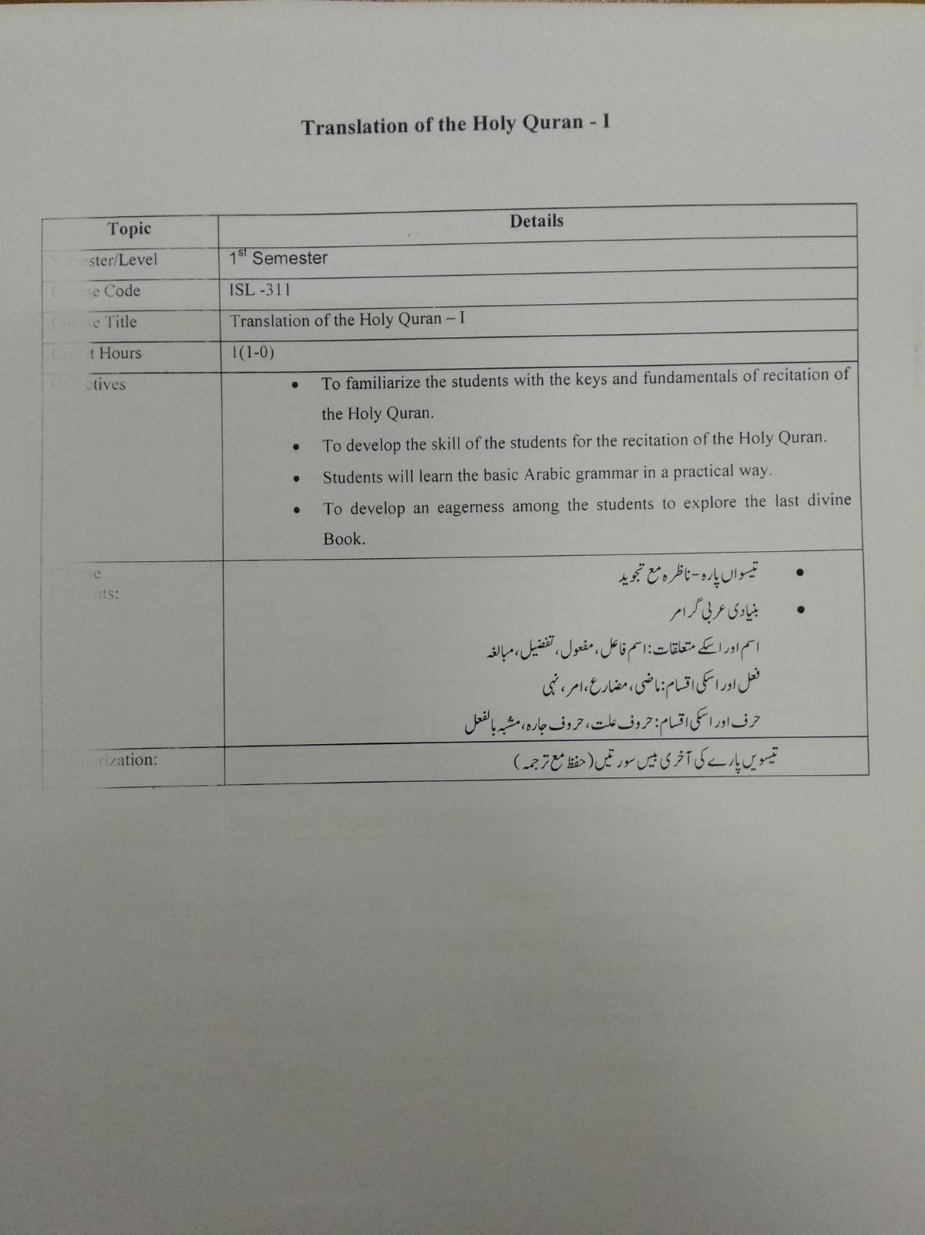

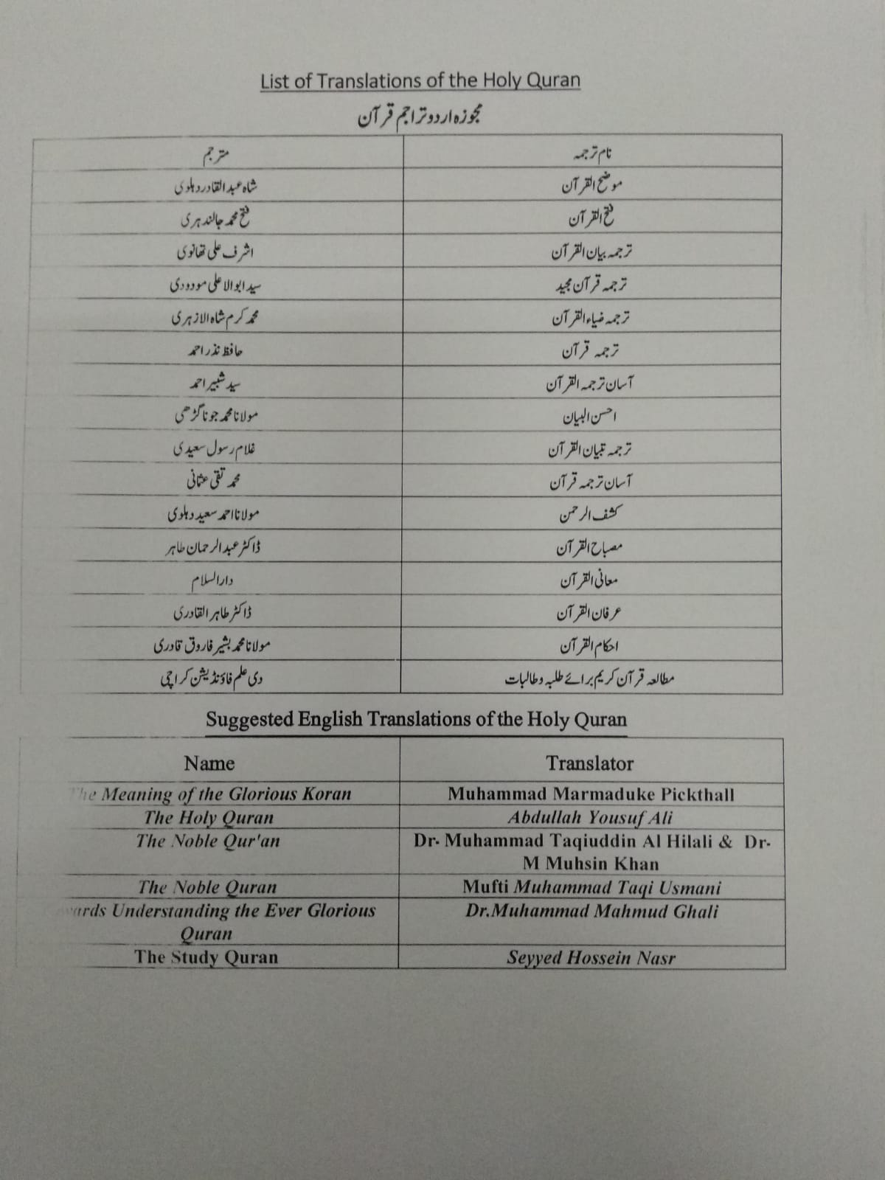

Semester - II

Code: ENG-322 | ENGLISH COMPREHENSION AND COMPOSITION | Credit Hours: 3(3-0)

CONTENTS

- Reading Comprehension Skills
- identifying main idea/topic sentences
- find specific information quickly
- distinguishing between relevant and irrelevant information according to purpose for reading
- recognizing and interpreting cohesive devices
- distinguishing between fact and opinion
- Reading techniques- applying Skimming, Scanning, SQ3R, SPRE
- C. Vocabulary Building Skills
- • guessing the meanings of unfamiliar words using context clues
- • using word formation rules for enhancing vocabulary
- • using the dictionary for finding out meanings and use of unfamiliar words
- D. Pre-writing Techniques- Brain Storming, making a list, Mind mapping.
- E. Writing Techniques:
- • Plan writing: identify audience, purpose and message
- • Collect information in various forms such as mind maps, tables, charts, lists
- • Order information such as:
- o Chronology for a narrative
- o Stages of a process
- o From general to specific and vice versa
- o From most important to least important
- o Advantages and disadvantages
- o Comparison and contrast
- o Problem solution pattern
- • Write argumentative and descriptive forms of writing using different methods of developing ideas like listing, comparison, and contrast, cause and effect, for and against
- F. Paragraph Writing:
- • Structure & Development of Paragraph.
- • Write and Identify good topic and supporting sentences and effective conclusions.
- • Use appropriate cohesive devices such as reference words and signal markers
- G. Types of Writing
- • Narrative
- • Descriptive: describing a place, character description

- • Expository
- • Argumentative
- H. Essay writing techniques:
- • Structure and outline of an essay.
- • Writing Introductions and conclusions of an essay.
- • Unity and coherence in an essay

- I. Paraphrasing: What is Paraphrase? Paraphrasing Techniques and how to apply
- J. Précis writing
- • What is Précis?
- • Uses of précis writing
- • Essentials of a good précis
- • Method of procedure
- • How to find the title
- • Précis of a phrase or clause
- • Précis of a Sentence
- • Précis of a Paragraph
- • Summarizing an article
- • Writing an assignment summary
- K. Expansion: Expansion of a sentence into paragraph

Method of Expansion
Suggested Books:
➢ Reading. Upper Intermediate. Brain Tomlinson and Rod Ellis.
➢ Oxford Supplementary Skills. Third Impression 1992.
➢ College writing skills by John Langan. McGraw Hill Publishers, 2004
➢ Reading upper intermediate. Brain Tomlinson and Rod Ellis. Oxford supplementary skills. Third impression 1992

Code: PST-321 | PAKISTAN STUDIES | Credit Hours: 02(2-0)

OBJECTIVES
- To develop vision of historical perspective, government, politics, contemporary Pakistan, and ideological background of Pakistan.
- To study the process of governance, national development, issues arising in the modern age and posing challenges to Pakistan.

COURSE OUTLINE

Historical Perspective
- Ideological rationale with special reference to Sir Syed Ahmed Khan, Allama Muhammad Iqbal and Quaid-e-Azam Muhammad Ali Jinnah
- Factors leading to Muslim separatism
- People and Land
- Indus Civilization
- Muslim advent
- Location and geo-physical features.
Government and Politics in Pakistan
Political and Constitutional phases:
- 1947-58
- 1958-71
- 1971-77
- 1977-88
- 1988-99
- 1999 onward
Contemporary Pakistan
- Economics institutions and issues
- Society and social structure
- Ethnicity
- Foreign policy of Pakistan and challenges
- Futuristic outlook of Pakistan

BOOKS RECOMMENDED

- Burki, S. J. (1980). State & society in Pakistan. The Macmillan Press Ltd.
- Akbar, S. Z. (2000). Issue in Pakistan’s economy, Karachi: Oxford University Press.
- Burke, S. M. &Ziring, L. (1993). Pakistan’s foreign policy: An historical analysis. Karachi: Oxford University Press.
- Safder, M. (1994). Pakistan political roots & development. Lahore: Idara-e- Saqafat-e-Islamia.
- Wilcox, W. (1972). The emergency of Bangladesh. Washington: American Enterprise, Institute of public research.
- Ziring, L. (1980). Enigma of political development. England: WmDawson& sons Ltd.
- Zahid, A. (1980). History and culture of Sindh. Karachi: Royal Book Company.
- Afzal, M. R. (1998). Political parties in Pakistan. Vol. I, II, & III. Islamabad: National Institute of Historical and Culture Research.

Code: PSY-302 | INTRODUCTION TO PSYCHOLOGY-II | Credit Hours: 04(3-1)

OBJECTIVES
1. To describe Basic understanding of human functioning.
2. To distinguish between the basic and higher order functions in human thought and behavior.
3. To gain insight into human behavior and into one’s own personality or personal relationships.

Course Contents:
Motives
• Definition and Nature
• Factors effecting Motives
Primary Motives: Hunger, Thirst, Defection and Urination, Fatigue, Sleep, Pain, Temperature Regulation, Maternal Behavior, Sex.
Secondary Motives: Play & Manipulation, Exploration and Curiosity, Affiliation, Achievement and Power, Competition, Cooperation, Social Approval and Self Actualization.
Emotions
• Definition and Nature
• Theories of Emotion (James Lange Theory; Cannon Bard Theory, Schachter-Singer Theory)
Learning
• Definition of Learning
• Types of Learning: Classical and Operant, Conditioning
• Methods of Learning: Trial and Error; Learning by insight; Observational Learning, learning by Reinforcement
Memory
• Definition and Nature
• Memory Processes: Retention, Recall and Recognition
• Forgetting: Nature and Causes
Thinking
• Definition and Nature.
• Tools of Thinking; Imagery; Language; Concepts
• Kinds of Thinking
• Problem Solving; Decision Making; Reasoning

• Individual Differences
• Definitions of the Concepts
• Intelligence, Personality, Aptitude, Achievement

Practicum:
Following experiments shall be performed by the students:
• Concept Formation
• Rumors building
• Memory: Function of Recitation
• Memory: Function of Time Saving Method
• Memory: Method of Serial Reproduction
• Recall and Decay

BOOKS:
Recommended:
1. Myers, D.G (2013). Introduction t to psychology. Open University Press.
2. Hayes, N (2010). Foundation of psychology (8th Ed.). Thomson publishers.
Reference
1 Atkinson R. C. & Smith E. E. (2000). Introduction to psychology (13th Ed.). USA:
Harcourt Brace College Publishers.
2 Fernald, L.D, & Fernald, P. S. (2005). Introduction to psychology. USA: WMC Brown
Publishers.

Code: STA-321 | INTRODUCTION TO STATISTICAL THEORY | Credit Hours: 03(2-1)

OBJECTIVES

- To enable the students to use the terms and concepts to learn the Scientific Method.
- To introduce statistical techniques employed within contemporary Psychology.
- To use statistics in learning basic data analysis techniques.
COURSE CONTENT

Introduction
- Basic Terms, Importance of Statistics in Psychology, Limitations of Statistics
Frequency Distribution and Graphic Representation of Data
- Data, Types of data, Frequency Distribution, Cumulative Frequency Distribution, Histogram, Polygon, Pictograph, Bar Diagram, Pie Chart,
Measures of Central Tendency
- Mean, Median, Mode
Measures of Variability
- Range, Mean Deviation, Quartile Deviation, Variance, Standard Deviation, Shepherd’s Correction, Coefficient of Variance, Z score
Correlation and Regression
- Correlation & Causation
- Pearson Product Moment Correlation
- Spearman’s Rank Order Correlation
- Linear Regression
- Scatter Diagram
- Standard Error of Estimation

Probability Binomial and Normal Distributions
- Permutation and Combination
- Definition of Probability
- Subjective Empirical and Classical Approach to Probability
- Laws of Probability
Hypothesis Testing / Test of Significance
- Z-Test
- t-Test
- f-Test
- Chi-Square
Analysis of Variance
- One-way classification
- Two-way classification

Non-Parametric Statistics
Note: Practical exercise will be given by the end of each topic / chapter.

Books Recommended
1. David , S.M. (1999). Introduction to Practice of Statistics.
2. Gravatter&Wallnan (2004) Statistics for behavioral sciences.
3. Thorne &Giesen (2000) Statistical for behavioral sciences.
4. Kinear, P.R. & Gray, C.D. SPPS for windows made simple
5. David, C. Howell (2005) Statistical Methods for Psychology (5th Edition).
6. RusselHurlburt (2003) Comprehensive behavior statistics.

Code: CSI-321 | INTRODUCTION TO COMPUTER APPLICATION | Credit Hours: 03(3-0)

OBJECTIVES:
- To provide students with an opportunity to develop an understanding of the basic operations of a computer system and computer application software. Meanwhile, they also develop the skill of using computer application software for solving problems.

COURSE CONTENTS:

Computer and its components
- Input and input devices
- Output and output devices
- Central processing unit
- Memory

Generations of Computer
- First generation
- Second generation
- Third generation
- Fourth generation
- Fifth generation

Types of Computers
- Analog Computers
- Digital Computers
- Hybrid Computers

Softwares
- Application software
- System software

Programming Language
- Low level languages
- High level languages
- use the Taskbar, Menus, Dialog Boxes, and Toolbars;
- Use Internet Explorer to search the World Wide Web, use email, download and print graphics
- Use Microsoft Word to create, retrieve and modify documents at an introductory level.
- Use Microsoft Excel to create, retrieve, modify and print spreadsheets and graphs at an introductory level
- Implementation of all excel concept including formulas and functions.
- Use Microsoft Access to construct and search a simple database.
- Use Microsoft PowerPoint to create a computer slide show.

Recommended Books:
- Gilbert, B. Introduction to Computer Science: A Textbook for Beginners in Informatics
- Joan, L., & Curtis, F. Microsoft office 2016 step by step
- Kinear, P.R. & Gray, C.D. SPPS for windows made simple
- Thorne &Giesen (2000) Statistical for behavioral sciences
- David, C. Howell (2005) Statistical Methods for Psychology (5th Edition).
- RusselHurlburt. ( 2003) Comprehensive behavior statistics.
- Person, Ron., Christopher, V. B. & Shelley O’ ara (1994). Using excel version 5 (k) for windows. Indian polis: Que Corporation.

Semester - III

Code: ENG-421 | COMMUNICATION SKILLS | Credit Hours: 03(3-0)

CONTENTS

Introduction to Communication
- Definition
- The process of communication
- Types of Communication
- Network of Communication
- 7 C’s of Communication
- Barriers of Communication(noise and classification of noise)
- How to overcome Barriers
Active Listening
- What is listening?
- Types of Listening
- Objectives
- Traits of a good Listener
- Active Listening- an Effective Listening Skill
- Note Taking Tips
- Barriers for Good Listening
- Purpose of Listening
- Outlines and Signposting
Oral communication/ Presentation skills
- Successful persuasive public speaking
- Importance of oral communication
- Effective Presentation strategies
- Defining the purpose of presentation and analyzing audience and locale
- Organizing contents and preparing outline
- Visual aids
- Nuances’ of delivery: Kinesics, proxemics, Paralinguistic, Chronemics
Interviews
- Preparing for interviews (scholarship, job, placement for internship, etc.)
- Types of Interviews
- Tips for successful Interviews
- 7Department of English, GCUF
- Prepared by: Noor ul Qamar Qasmi, Head,Department of English

Reading skills
- Importance of Reading
- Definition of Reading
- Levels of Reading
- Requirements of Reading, improving reading rates and comprehension
- Types of Reading (intensive and extensive, and speed reading)
- Study skills

Writing
- Writing formal letters
- Memos writing, minutes of meetings,
- Writing different kinds of applications (leave, job, complaint, etc.)
- Preparing a Cover Letter, Curriculum Vitae (CV) and Resume
- Writing reports
- Types of reports, structure of reports
- Progress report writing
- How to write a proposal for research paper/term paper
- How to write a research paper/term paper (emphasis on style, content, language, form, clarity consistency)
- Technical Proposals writing

Recommended Readings:
Ellen, K. 2002. Maximize Your Presentation Skills: How to Speak, Look and Act on Your Way to the Top
Hargie, O. (ed.) Hand book of Communications Skills
Mandel, S. 2000. Effective Presentation Skills: A Practical Guide Better Speaking
Mark, P. 1996. Presenting in English. Language Teaching Publications

Code: PSY-401 | HISTORY AND SYSTEMS IN PSYCHOLOGY | Credit Hours: 03(3-0)

OBJECTIVES
- To acquaint the learners with an overview of the background of present-day psychology.
- To promote basic understanding of the various processes of scientific development and transformation.
- To make students familiar with the chronological history of ideas which contribute to the field of Psychology
- To learn the major figure and school of thoughts in the history of psychology.

COURSE CONTENTS

Philosophical Influences on Psychology
- Greek philosophers/thinkers

Physiological & Muslim Influence on Psychology
- Developments in early Physiology
- Beginning of experimental Psychology
- Formal foundation- Dark Ages and Renascence of Psychology

New Psychology
- Wilhelm Wundt
- The German Influence

Introduction to Schools of Thought
- Structuralism
- Functionalism
- Behaviorism
- Neo Behaviorism
- Gestalt
- Psychoanalysis
- Humanistic
- Existentialism
- Cognitive

Contemporary Status of Various Areas of Psychology
Social Psychology, Clinical Psychology, Military Psychology, Developmental Psychology, Industrial and Organizational Psychology, Psychometrics, Personality Psychology, Educational and Counseling Psychology, Experimental Psychology, Physiological Psychology, Psychology of Mass Communication, Advertisement and Consumer Behavior,

Recent Scope and Status of Psychology in Pakistan

BOOKS Required (students must buy)
Hergenhahn, B. R., & Henley, T. (2013). An introduction to the history of psychology. Cengage Learning.

Recommended (would be useful to students)
Schultz, D. P., & Schultz, S. E. (2015). A history of modern psychology. Cengage Learning.

Reference (do not buy, read if available in library/elsewhere)
Goodwin, C. J. (2015). A history of modern psychology. John Wiley & Sons.
King, D. B., Woody, W. D., & Viney, W. (2015). History of Psychology: Ideas and Context. Routledge.
James, W., Burkhardt, F., Bowers, F., & Skrupskelis, I. K. (1890). The principles of Psychology (Vol. 1, no.2). London: Macmillan
Archives of the history of American Psychology www.apa.org/about/archives/index.aspx
BPS origins timeline at origins.bps.org.uk

JCR Journals (subject related and relevant)
- History of Psychology published by PsycNET URL https://www.apa.org/pubs/journals/hop
- Journal of History of the Behavioral Sciences URL https://onlinelibrary.wiley.com/journal/15206696

Code: PSY-403 | PERSONALITY PSYCHOLOGY | Credit Hours: 03(3-0)

OBJECTIVES
- To have a general, integrated and clear concept of Personality along with identification of important theories of personality
- To articulate the major personality theories in depth, focusing on each theory’s basic concepts, principles, and process of personality development
- To understand each theory’s assessment techniques along with the theory’s approach to the treatment and understanding of psychopathology

COURSE CONTENTS

Introduction to the Discipline
- What is Personality?
- Significance of Studying Personality
- Scientific Basis of Personality Psychology
- Criteria for Evaluating Scientific Theories

The Psychoanalytic Legacy: Sigmund Freud
- Biographical Sketch Sigmund Freud
- Basic Concepts and principles
- Personality Development
- Assessment and Therapeutic Techniques

Personality’s Ancestral Foundations: Carl Jung
- Biographical Sketch of Carl Jung
- Basic Concepts and principles
- Personality Development
- Assessment and Therapeutic Techniques

Overcoming Inferiority and Striving for Superiority: Alfred Adler
- Biographical Sketch of Alfred Adler
- Basic Concepts and principles
- Personality Development
- Assessment and Therapeutic Techniques

Contribution of Neo Freudians in Personality Psychology
- Karen Horny
- Harry Stack Sullivan
- Erik Erikson
- Erik Fromm

Contribution of Trait Theorists
- Gordon Allport
- Raymond Cattell
- Hans Eyseneck
- Recent Developments in trait approach
Contribution of Humanistic / Existential Theorists
- Abraham Maslow
- Carl Rogers

Social Learning Theories of Personality
- Albert Bandura and others
Note: In order to grasp knowledge of the field in depth, the students will have to give oral presentations along with written assignments on Personality Theories given by the following theorists:
Heinz Kohut, Henry A. Murray, Hans Eysenck, George Kelly, Rollo May, B.F. Skinner, Julian Rotter, John Dollard and Neal Miller

BOOKS
Required (Students must buy)
Schultz, D. P. & Schultz, S. E. (2013). Theories of personality (10th Ed.). New York: Wadsworth / Thomson Learning Inc.

Recommended (Would be useful for students)
Ryckman, R. M. (2008). Theories of personality (9th Ed.).USA: Wadsworth/Thomson Learning.
Allen, B, P. (1997). Personality theories: Development, growth and diversity (2nd Ed.). Boston:
Allyn & Bacon.

Reference (Do not buy, read if available in library/elsewhere)
Buss, D. M. (2004). Evolutionary psychology: The science of mind (2nd Ed.). Boston: Allyn &
Bacon.
Ewen, R. B. (1998). An Introduction to theories of personality (5th Ed.). New Jersey: Lawrence
Erlbaum Associate Publishers.
Pervin, L. A., Cervone, D. & John, O. P. (2005). Personality: Theory & research (9th Ed.). New
York: John Wiley & Sons.

JCR Journals
Journal of Personality Assessment, Taylor and Francis Online, URL:
https://www.tandfonline.com/loi/hjpa20
Journal of Personality and Social Psychology, American Psychological Association (APA). URL:
https://www.apa.org/pubs/journals/psp/
Journal of Research in Personality, Elsevier. URL: https://www.journals.elsevier.com/journal-of-research-in-personality
Personality and Social Psychology Bulletin, Sage Journals, URL:
https://journals.sagepub.com/home/psp
Personality and Social Psychology Review, Sage Journals. URL:
https://journals.sagepub.com/home/psr
Social and Personality Psychology Compass, Wiley Online Library. URL:
https://onlinelibrary.wiley.com/journal/17519004

Code: PSY-405 | SOCIAL PSYCHOLOGY | Credit Hours: 04(4-0)

OBJECTIVES
a. To provide substantial knowledge to the students of this field including major concepts, theories, empirical findings, and controversies.
b. To provide the opportunity to the students so that they may communicate critically and creatively about these theories and findings of social research.
c. To facilitate the students to apply the knowledge practically in society.

COURSE CONTENTS

Introduction to Social Psychology
- Nature and scope of social psychology

Social Perception and Cognition
- Self in Social World
- Attribution
- Schemas
- Heuristics
- Automatic and control processing
- Errors in social cognition

Socialization
- Nature: Perspectives of Socialization.
- Agents of Socialization
- Process of Socialization
- Socialization of Gender Roles

Attitudes
- Nature &Structure Formation of attitude
- Attitude Change
- Attitude Predicts Behavior

Stereotyping, Prejudice and Discrimination
- The Nature and Origins of Stereotyping
- Nature and power of prejudice
- Sources of prejudice
- Discrimination: Nature and causes
- Techniques for Countering its Effects

Social Influence
- Persuasion
- Conformity and Compliance
- Symbolic Social Influence
- Obedience to authority

Pro-social Behavior
- Theories of Pro-social Behavior
- Components and Motives for Pro-social Behavior
- Factors influencing the Tendency to Help
- Role of Emotions in Pro-social Behavior
- Empathy and Self Compassion
- Altruism

Groups Dynamics
- Types and Nature of Groups
- Effects of Presence of Others
  - Social Loafing
  - Social Facilitation
- Cooperation and Conflicts in Groups

- The Role of Leadership in Groups
Interpersonal Attraction, Close Relationships, and Love
- Internal Sources of Attraction
- External Sources of Attraction
- Factors Based on Social Interaction
- Close Relationships as Foundations of Social Life

Aggression
- What is aggression?
- Theories of aggression
- Influences on aggression
- How can aggression be reduced?

BOOKS
Required (Students must buy)
Myers, D. G., &Twenge, J. M. (2020). Exploring social psychology. Retrieved from https://www.amazon.com/Social-Psychology-David-Myers/dp/1260397114
Baron, R. A., & Branscombe, N. R. (2012). Social psychology (13th Ed.). New York: Pearson
Recommended (Would be useful for students)
Abrams, D., & Hogg, M. A. (2006). Social identifications: A social psychology of intergroup
relations and group processes. Routledge.
Myers, D. G., & Smith, S. M. (2012). Exploring social psychology. New York: McGraw-Hill.
Fiske, S. T., Gilbert, D. T., & Lindzey, G. (2010). Handbook of social psychology (Vol 1). John Wiley & Sons.
Dovidio, J. F., Piliavin, J. A., Schroeder, D. A., &Penner, L. A. (2017). The social psychology of prosocial behavior. Psychology Press.
Forsyth, D. F. (1987). Social psychology. California: Brooks Publishing Company
Education, Inc.
Baumeister, R. F., & Finkel, E. J. (Eds.). (2010). Advanced social psychology: The state of the
science. OUP USA.
Feldman, R. S. (1998). Social psychology: Theories, research and application. New York:
McGraw-Hill.
Reference (Do not buy, read if available in library/elsewhere)
McDougall, W. (2015). An introduction to social psychology. Psychology Press.
Tajfel, H. (Ed.). (2010). Social identity and intergroup relations (Vol. 7). Cambridge University
Press.
Thibaut, J. W. (2017). The social psychology of groups. Routledge.
JCR Journals
European Journal of Social Psychology, Wiley Online Library. URL: 3https://onlinelibrary.wiley.com/journal/10990992
Journal of Personality and Social Psychology, American Psychological Association (APA). URL:
https://www.apa.org/pubs/journals/psp/
Pakistan Journal of Social and Clinical Psychology, Department of Psychology, GC University,
Lahore. URL: https://www.gcu.edu.pk/Soc&ClinPsyJour.htm
Personality and Social Psychology Bulletin, Sage Journals, URL:
https://journals.sagepub.com/home/psp
Personality and Social Psychology Review, Sage Journals. URL:
https://journals.sagepub.com/home/psr
Social and Personality Psychology Compass, Wiley Online Library. URL:
https://onlinelibrary.wiley.com/journal/17519004

Code: EDU-503 | FOUNDATION OF EDUCATION | Credit Hours: 03(3-0)

Socio Economic foundations
- Concept of Society and Culture
- Social Conditions and Education
- Economic Conditions and Education
- Politics and Education

Historical Foundations
- Period from 1947-1958
- Period From 1959-1971
- Period from 1972-1979
- Period from 1980 -1991
- Period from 1992 – to date

Education System of Pakistan
- Primary Education
- Secondary Education
- Higher Education
- Examination System
Curriculum Development
- Elements of curriculum
- Curriculum development process in Pakistan
- Curriculum change

Classroom Assessment
- Characteristics of a test
- Types of test items

Psychology of Exceptional children

Lesson Planning
- Need & Importance of lesson planning
- Preparation of lesson planning

Recommended books:
1. Corno. Lyn, Eric M. Anderman, (2012)Handbook of Educational Psychology. New York: Rutledge publications
2. Boyle,Bill (2015) Curriculum Development; Jim Ryder Publishers:UK
3.Miller, M. David.,Linn,L. Robert., Grounald,E .Norman (2009) Measurement and Assessment in Teaching; Newyork:Pearson
4.Rosenshine, B. (2010). Principles of instruction (Educational Practice Series No. 21). Geneva: Retrieve from http://www.ibe.unesco.org/en/services/online-materials/publications/educational-practices.html

5.Vosniadou, S. (2001). How children learn. (Educational Practice Series No. 7). Geneva: International Bureau of Education. Retrieve from http://www.ibe.unesco.org/en/services/online-materials/publications/educational-practices.html

6.What Makes a Good Teacher? Opinions from Around the World. Retrieve from

Code: ISL-411 | TRANSLATION OF THE HOLY QURAN-II | Credit Hours: 01(1-0)

Semester - IV

Code: ENG-422 | TECHNICAL WRITING | Credit Hours: 03(3-0)

Objective
To enable the students to meet their real life writing skills
Course Contents:
Paragraph writing
Practice in writing a good, unified and coherent paragraph
Essay Writing
Introduction and Technical aspects of essay writing
CV and Job Application
Translation Skills (Urdu to English)
Study Skills
Skimming and scanning, intensive and extensive, and speed reading, summary and prices writing and comprehension
Academic Skills
Letter/memo writing, minutes of meetings, use of library and internet
Presentation Skills
Personality development (emphasis on content, style and pronunciation)
Note: Documentaries to be shown for discussion and review
Books Recommended
- Boutin, M. C., Brinand, S., &Grellet, F. (1993). Writing: Intermediate Oxford supplementary skills (4th impression). Oxford university press.
- Thomson, A. J. & Martinet, A. V. (1986). Practical english grammar (3rd Ed.) Oxford university press.
- Tomlinson, B. & Ellis, R. (1992). Reading upper intermediate; Oxford supplementary skills (3rd Impression). Karachi: Oxford University Press.

Code: PSY-402 | DEVELOPMENTAL PSYCHOLOGY | Credit Hours: 04(4-0)

OBJECTIVES
- Be able to demonstrate a broad working knowledge of developmental psychology by providing an overview of basic principles related to biosocial, cognitive and psychosocial changes throughout the entire lifespan.
- Be able to demonstrate an understanding of different stages of development through the lifespan.
- Identify and apply developmental concepts to everyday life.
- Demonstrate improved critical thinking and communication skills.
- Identify major theorists that contribute to the field of developmental psychology.

COURSE CONTENTS

Introduction
- Nature & Historical Perspective of Developmental Psychology
- Research Methods for Developmental Changes
- Ethics in Research on Life Span Development
- Theories Of Interpreting The Lifespan

Prenatal Development
- Prenatal Development
- Genetic Influences in Development
- Environmental and psychological Influences

Infancy
- Physical Development
- Cognitive Development in infancy with reference to Piaget’s theory.
- Language Development in Infancy
- Socio-emotional Development in Infancy

Childhood
- Physical Development
- Cognitive Development
- Personality Development (Role of familiar/extra-familiar influences)

Adolescence
- Physical Development
- Social Development
- Ego-identity

Early Adulthood
- Physical Development
- Family and occupational adjustment

Middle Age
- Physical changes
- Social adjustment
- Family and occupational adjustment

Gerontology
- Approaches of children to death
- Approaches of adults to death
- The elderly and death
- Bereavement and death

Required Book
Santrock, J.W. (2018).Life-span Development (17th Ed.) McGraw Hill

Recommended Books
- Daccey, J.S. and Travers, J.F. (2008) Human Development (7th Ed.) McGraw Hill .
- Hetherington, E.M. and Parke, R.D. (2008) Child Psychology (7th Ed) McGraw Hill

Reference Book
Shaffer, D.R. and Kipp , K(2010) Development psychology Childhood and Adolescence ( 8th Ed.) Wadsworth

Harris, M and Butterworth G (2002) Developmental Psychology A Student's Handbook (1st Ed) Psychology Press

JCR Journal
Journal Of Adult Development
Journal Of Youth And Adolescence

Code: PSY-404 | COGNITIVE AND AFFECTIVE PROCESSES | Credit Hours: 04(3-1)

Objectives
- To understand the present methodologies and concepts in cognitive psychology.
- To understand and critically evaluate theory and research in cognitive psychology/neuroscience
- To develop technical and conceptual expertise in evaluating cognitive and affective research methods
- To be able to apply recent developments in cognitive/affective psychology and neuroscience to their own work.
- To identify and understand sources of individual differences and diversity in cognitive abilities and processes
Introduction to Cognitive Psychology
- History & Research Methods in Cognitive Psychology
- Paradigms of Cognitive Psychology
Sensation and Perception
- Conceptualization of sensation and perception
- Pattern Recognition & Feature Analysis
- Mental Imagery
- Gestalt Approaches to Perception
- Visual Illusions
- Bottom-Up and Top Down Processes
- Motivational determinants of perception
Attention
- Capacity Models
- Selective & Divided Attention
- Attention and Executive Control
- Automaticity and frequency

Concept and Categorization
- Introduction and Preliminary Issues
- Theoretical Models (Classical, Probabilistic Featural, Dimensional and Holistic Approach, the Exemplar View)
- Implications
Memory
- Theories of Memory
- The storage and retrieval processes
- Memory experiments
- Mnemonics (ways of improving memory)
Use & Manipulation of Information
- Language
- Thinking and problem solving
- Reasoning & Decision Making
Feelings and Emotions
- Nature and types of feelings & Emotions
- Theories of Emotions
- Theoretical models of cognition and affect
- Facial and vocal expressions in Emotions
Metacognition and Meta-mood
- Introduction
- Basic Meta Cognitive judgments
- Measurement of Metacognition
- Applications of Meta Cognition
- Individual Meta-Mood experiences
- Measurement of Meta-Moods
- Application of Meta-Moods
PRACTICUM
Students will perform at least 10 practices out of the following list
  - Study of depth perception
  - Detection of Threshold
  - Measurement of Differential Threshold
  - Problem solving
  - Automaticity (STROOP task)
  - Retroactive and Proactive Inhibition
  - Mental Imagery
  - Emotion Recognition Task
  - Mood Induction
  - Attention Span
  - Color zones of Retina
  - Measurement of Emotion
  - Memory Span
  - Measurement of Reaction Time
  - Measurement of Memory changes
  - After Image
  - Visual Illusions
  - Measurement of Memory Changes

Practicum will cover the following aspects
- Objectives
- Introduction of the experiment
- Material
- Procedure
- Results and interpretations
- Materials / Protocols

BOOKS
Required (students must buy)
Galotti, K. M. (2017). Cognitive psychology in and out of the laboratory. Sage Publications.
Recommended (would be useful to students)
Solso, R. L., MacLin, M. K., & MacLin, O. H. (2005). Cognitive psychology. Pearson Education New Zealand.
Hunt, R. R., & Ellis, H. (2018). Fundamentals of Cognitive Psychology (7th ed).
Reference (Do not buy, read if available in library/elsewhere)
Weiten, W. (2007). Psychology: Themes and variations: Themes and variations. Cengage Learning.
Smith, E. E., & Medin, D. L. (1981). Categories and concepts (Vol. 9). Cambridge, MA: Harvard University Press.
Goldstone, R. L., & Kersten, A. (2003). Concepts and categorization. In A. F. Healy & R. W. Proctor (Eds.), Handbook of psychology: Experimental psychology, Vol. 4, pp. 599-621). Hoboken, NJ, US: John Wiley & Sons Inc.
JCR Journals (Subject related and relevant)
- Trends in Cognitive Sciences published by Elsevier BV URL https://www.sciencedirect.com/journal/trends-in-cognitive-sciences
- Cognition and Emotion published by Taylor & Francis URL https://www.tandfonline.com/toc/pcem20/current

Code: PSY-406 | BEHAVIORAL NEUROSCIENCES | Credit Hours: 04(4-0)

OBJECTIVES
- To provide the understanding with the present methodologies, techniques and important concepts in the area of psychophysiology/ behavioral neuroscience.
- To review the biological and physiological processes/ functioning underlying the cognitive/ behavioral processes (i.e., emotions and motivation)
- To instill an ethical approach to conduct the experimental research in the area of behavioral neurosciences.
- To understand the etiological factors (neuro-physiological) involved in the brain damage and possible remedies.
- To review the effects of various neurological abnormalities on human behavior and psychological functioning.
- To enable the students to understand the causal (neuro- biological and neuro-chemical) factors involved in the psychiatric disorders observed in the clinical settings
- Students’ knowledge will enable them to formulate the case based on their understanding of the psycho-physiological processes
COURSE CONTENTS
- Origins of Neuro-psychology
- Neurological explanation of behavior
- Historical roots of Physiological Psychology
- Evolution of brain
- Genetics and evolution of behavior
- Ethical issues in neuropsychological research
- Psychology of Nerve Cells/ Neurons
- Neurons (internal/ external structure)
- Types of neurons (function and structure wise)
- Nerve impulse
- Communication within a neuron
- Communication between neurons
- Physiology of Nervous System
- Development of human brain
- Basic features of nervous system
- Central Nervous System
- Peripheral Nervous system
- Investigating how the brain controls various behaviors and endocrine system

- Emotions and Regulation of Internal Body States
- Neural control of emotional response patterns
- Role of orbito- frontal cortex in social judgment and emotions
- Neural basis of the communication of emotions
- Endocrine system and its role in emotions
- Motivation
- Homeostasis
- The psychology and biology of thirst
- Physiological and neurological mechanisms of hunger, role of exocrine glands
- Physiological mechanisms of sleep and waking
- Brain Damage
- Causes of Brain Damage
- Neurological / Neuropsychological Disorders
- Organic Brain Syndrome
- Epilepsy
- Psychiatric disorders with organic / biological etiology i.e.,
Affective disorder, Anxiety disorders, Psychotic disorders
- Mental retardation
- Sleep disorders
- Migraine
- Tumors; Types of Brain Tumors
- Amnesia

BOOKS
Required:
Carlson, N. R., & Birkett, M.A. (2017). Physiology of behavior. (12th ed.). UK: Pearson.

Recommended:
Pinel, J. P. J. (2014). Biopsychology. Harlow, Essex: Pearson Education Limited.

Reference:
Garrett, B. (2015). Brain and behavior: An Introduction to biological psychology. (4th ed.). SAGE Publications, Inc.
Kalat, J. W. (2013). Biological Psychology. (11th ed.). USA: Wadsworth.
Kolb, B., & Whishaw, I. Q. (2003). Fundamentals of human neuropsychology. (5th ed.). New York, NY, US: Worth Publishers.

JCR Journals
Current Topics in Behavioral Neurosciences, Springer, URL: https://www.springer.com/series/7854
European Journal of Neurology, Wiley Online Library, URL: https://www.wiley.com/en-us/European+Journal+of+Neurology-p-9780JRNL59699
European Neurology, Karger Publishers, URL: https://www.karger.com/Journal/Home/223840
Journal of Neuropathology and Experimental Neurology, American Association of Neuropathologists, URL: https://academic.oup.com/jnen
Journal of Neuropsychiatry and Clinical Neurosciences, American Psychiatric Association Publishing Powered by Atypon Literatum, URL: https://neuro.psychiatryonline.org/
Journal of Neurology, Neurosurgery and Psychiatry, BMJ Publishing Group, URL: https://jnnp.bmj.com/
Journal of Neurochemistry, Wiley Online Library, URL: https://onlinelibrary.wiley.com/journal/14714159
Journal of Neuroscience, Society for Neuroscience, URL: https://www.jneurosci.org/
Journal of Neuroscience research, Wiley Periodicals, Inc, URL: https://onlinelibrary.wiley.com/journal/10974547
Journal of Neurophysiology, American Physiological Society, URL: https://journals.physiology.org/journal/jn
Psychophysiology, Wiley Online Library, URL: https://onlinelibrary.wiley.com/journal/14698986

Code: MPH-601 | FOUNDATION OF PUBLIC HEALTH | Credit Hours: 03(3-0)

OBJECTIVES

By the end of the course participants should be able to:
- Examine public health through its historical context and use this information in the evaluation of current public health issues
- Analyze a public health problem and evaluate interventions and policy alternatives using the problem-solving methodology
COURSE CONTENTS

Definition of public health in a historical perspective public health and its history
● Social, political, and economic determinants of health
● Impact of health disparities on race, class and gender
● Moral and legal foundations
● Public health structures
● Historical trauma
● Cultural competence
● Health and human rights
● Financing & advocacy
● Health equity
● Communication
Recent developments in public health and future directions of public health

Problem-solving methodology applied to public health
- Defining the problem
- Measuring the magnitude of the problem
- Developing a conceptual framework for understanding the key determinants
- Identifying and developing strategies (policies and interventions)
- Setting priorities and recommending intervention or policies
- Implementing interventions or policies and evaluation plan
- Developing a communication strategy
Research in public health and importance of evidence-based decision making

Overview of public health programs in Pakistan

Teaching Methodology:
The methodology used ranges from didactic and participative lectures, discussions to practical problem solving exercises.

RECOMMENDED BOOKS
1. Basch PF. Textbook of international health, 2ndEd. New York, NY:OxfordUniversity Press.
2. Brownson RC, Baker BA, Leet TL, Gillespie KN. Evidence-based public health. New York, NY: OxfordUniversity Press; 2003.
3. Detels R, McEwen J, Beaglehole R, Tanaka H, (eds.). Oxford textbook of public health: the practice of public health, 4th ed. Oxford: Oxford University Press; 2002.
4. Malin N, Wilmot S, Manthorpe J. Key concepts and debates in health and social policy. Philadelphia, PA: Open University Press; 2002.
5. Porter D. Health, civilization and the state, 1st ed. New York, NY: Chapman and Hall Routledge; 1999.
6. Rohde J, Wyon J. Community-based health care lessons from Bangladesh to Boston, 1st ed. Cambridge, MA: Management Sciences for Health in collaboration with the Harvard ; 2002.
7. Schneiderman N, Speers MA, Silva JM, Tomes H, Gentry JH (eds.). Integrating behavioral and social sciences with public health, 1st ed. WashingtonDC: American Psychological Association; 2001.
8. Tulchinsky TH, Varavikova EA. The new public health: an introduction for the 21st century. San Diego, CA: Academic Press; 2000

Semester - V

Code: PSY-501 | PSYCHOLOGICAL TESTING AND MEASUREMENT – I | Credit Hours: 03(3-0)

OBJECTIVES
- To introduce the students with basic theoretical psychometric concepts and uses and limitations of psychological testing.
- To equip the students with understanding of the basic principles of psychological testing and measurement, techniques of test construction, establishment of psychometric properties, standardization, administration, and scoring.
- To introduce the students with concepts and types of Psychometric properties (i.e., Reliability and Validity) of the psychological tests along with hands-on practical exposure using SPSS.

COURSE CONTENTS

Introduction
- Definition, Nature and Uses of Psychological Testing
- Limitations and Controversies in Psychological Testing

Historical Perspective and Origins of Psychological Testing
- Psychological Testing Before 19th Century
- Major Developments During 19th Century
- Current Status of Psychological Testing

Types of Psychological Tests

- Neuropsychological assessment
- Personality assessment
- Intellectual assessment
- Academic assessment
- Employees assessment
- Other assessments

Test Administration
- Examiner’s Duties Before Testing
- Examiner’s Duties During Testing
- Examiner’s Duties After Testing

Test Scoring
- Scoring of Essay Type Tests
- Scoring of Oral Tests
- Scoring of Objective Tests

Test Construction
- Nature and Types of Items
- Item Selection and Item Writing
- Expert Validation and Pilot Testing
- Data Collection and Factor Analysis
- Test Standardization / Establishment of Psychometric Properties
- Norming the Test (Types of Norms and the Process of Norming)
- Test Publication and Revision
- Item Analysis: (Difficulty Analysis, Discrimination Analysis, and Distracters Analysis)

Reliability
- Definition & Types of Reliability
- Error of Measurement, True and Error Variances
- Reliability of Speed Tests
- Factors influencing Reliability
- Reliability Analysis using SPSS

Validity
- Definition & Types of Validity
- Cross validation
- Factors affecting Validity
- Validity Analysis using SPSS

BOOKS Required (Students must buy)
Urbina, S. (2014). Essentials of psychological testing. John Wiley & Sons.
Anastasi, A., & Urbina, S. (1997). Psychological testing. New York: Prentice-Hall, Inc.

Recommended (Would be useful for students)
Aiken, L. R. & Groth-Marnat, G. (2009). Psychological testing and assessment (12th Ed.). Allyn
& Bacon.
Groth-Marnat, G. (2009). Handbook of psychological assessment. John Wiley & Sons.
Cooper, C. (2019). Psychologcal testing: Theory and practice. New York: Routledge.

Reference (Do not buy, read if available in library/elsewhere)
DeVellis, R. F. (2003). Scale development: Theory and practice (2nd Ed.). Sage Publications,
Inc.
Gregory, R. J. (2017). Psychological testing: History, principles, and applications (7th Ed.).
Pearson Education, Inc.
Kline, P. (2013). Handbook of psychological testing. Routledge.
Kline, P. (2015). A handbook of test construction (psychology revivals): introduction to
psychometric design. Routledge.
Loewenthal, K., & Lewis, C. A. (2018). An introduction to psychological tests and scales.
Psychology Press.
Thorndike, R. M., & Thorndike-Christ, T. M. (2010). Measurement and evaluation in
psychology and education. Pearson Education, Inc.

JCR Journals
European Journal of Psychological Assessment (EJPA), European Association of Psychological
Association (EAPA). URL: https://us.hogrefe.com/products/journals/european-journal-of-psychological-assessment
Journal of Personality Assessment, Taylor and Francis Online, URL:
https://www.tandfonline.com/loi/hjpa20
Psychological Assessment, American Psychological Association (APA). URL:
https://www.apa.org/pubs/journals/pas/

Code: PSY-503 | MENTAL HEALTH AND PSYCHOPATHOLOGY-I | Credit Hours: 03(3-0)

OBJECTIVES
- To identify the role of psychopathology in individual’s mental health outcomes
- To investigate the core concept of psychopathology in the development of psychiatric disorders
- To understand psychopathology in current clinical practices
- To explain the mechanism and manifestation of abnormal behavior
- To educate the students that how psychopathology is important to investigate diagnosis

COURSE CONTENTS

Introduction to mental health & psychopathology
  - Defining mental health & psychopathology
  - Difference between normality and abnormality
  - Development of psychopathology

Historical Background of psychopathology
  - Ancient Demonology and Medieval Witchcraft
  - Philosophical Era and psychopathology
  - Modern concept of psychopathology
  - Different models of psychopathology
  - Current scenario in Pakistan

Psychopathology and Psychological Disorders
- Role and development of diagnostic criteria
- Scope and implications of the research base criteria

DSM Based classification of Psychopathology
- Introduction to DSM-V
- Significance of DSM-V based psychological disorders
- Use of the manual
- Advancement in the DSM from begging to current

Important aspects of diagnosis
- Diagnostic criteria
- Diagnostic features
- Differential diagnosis
- Etiological factors
- Other associated factors

Psychological Disorders
- Neurodevelopment disorders
- Depressive disorders
- Anxiety disorders
- Obsessive-compulsive and related disorders
- Personality Disorders

BOOKS Required (students must buy)
American Psychiatric Association. (2013). Diagnostic and statistical manual of mental disorders. (5th Ed. Text Revised). Washington, DC: American Psychiatric Association Press.

Recommended (would be useful to students)
Comer, R. J. (2004). Abnormal psychology. USA: Freeman & Company.
Neale, J. M. & Davison, G. C. (2004). Abnoral psychology. New York: John Wiley & Sons.

Reference (do not buy, read if available in library/elsewhere)
Summergrad, P., Silbersweig, d. A., Muskan, P. R., & Querques, J. (2020). Textbook of Medical Psychiatry. American Psychiatric Publishing, Incorporated. https://www.barnesandnoble.com/w/textbook-of-medical-psychiatry-paul-summergrad-md/1133987120

JCR Journals (subject related and relevant)
Journal of Mental Health. https://www.tandfonline.com/toc/ijmh20/current

Code: PSY-505 | RESEARCH METHODOLOGY – I | Credit Hours: 03(3-0)

OBJECTIVES:
- To provide an introduction to the basic logic of scientific methods of research.
- To provide students technical, comprehensive and updated knowledge and psychological research.
- To provide a quantitative empirical statement based on the statistical analysis of experimental data

COURSE CONTENTS

1. Introduction to Research

- Theoretical framework and methodological approaches in social research.
- Meaning, purpose and function of psychological research
- Scientific and non scientific approaches to knowledge

- The Scientific Method of Research
- Goals of the Scientific Method Operational Definitions
- Concepts, Constructs and Variables
- Research Question, Problem statement and Hypothesis
- Psychological Research Process
- Measurement Scales
4. Sampling Techniques
- Defining sample
- Probability and non probability sampling.
- Advantages and disadvantages of each type
- Sampling in qualitative and quantitative research

5. Methods of Data Collection
- Primary and Secondary Data
- Technique and methods of data collection
- Observation: Types, Advantages and Disadvantages,
- Interview: Types, Advantages and Disadvantages
- Survey Method
- Questionnaire: Types, Advantages and Disadvantages

6. Ethical Issues in Psychological Research
- APA ethical standards for conducting research

BOOKS Required (students must buy)
Shaughnessy, J. J. (2005). (6th,ed). Research Methods in Psychology. America: McGraw Hill.
Neuman, L. W. Social Research Methods: Qualitative and quantitative approaches, 7th Edition.
McBurney D. H (2004). Research Methods in Psychology. New York: Inc.
.

Recommended (would be useful to students)
Gravetter, F. J. (2003). Research Methods in Psychology. America: Wards Worth. Inc.
Neuman, N. (2005). Qualitative & Quantitative methods in social Research.
Willig, C. (2003). Introducing Qualitative Research in Psychology

Reference (do not buy, read if available in library/elsewhere)
American Psychological Association(2020). Research Manual. Seventh Edition.
Kumar, A. (2011). RESEARCH METHODOLOGY. A step-by-step guide for beginners. Third Edition. Sage Publication Ltd. London
Igwenagu, C, (2016). Fundamentals of research methodology and data collection. LAP Lambert Academic Publishing ( 2016-04-19 ).
JCR Journals (subject relat

Psychological Research
International Journal of Psychological Research

PSY-507 | APPLICATION OF STATISTICS IN PSYCHOLOGY | Credit Hours: 03 (2-1)

OBJECTIVES
a. To enable the students to use the terms and concepts to learn the Scientific Method.
b. To introduce statistical techniques employed within contemporary Psychology.
c. To use statistics in learning basic data analysis techniques.

COURSE CONTENTS

Introduction
- Basic terms (population, variables, measurement scales)
- Importance of statistics in psychology and various fields
Data Distribution and Presentation
- Meaning and types of data
- Methodology for data collection
- Frequency distribution
- Exploring data with graphs

Measures of Central Tendency and variability
- Mean, Mode, and Median
- Range, Mean Deviation, Quartile Deviation, Variance, and Standard Deviation
- Percentiles, Shepherd’s Correction, Coefficient of Variance, and z score
Normal & Binomial Distribution
- Normal distribution: Its properties and application
- Binomial distribution: Its properties and application.

Hypothesis Testing
- Testing Null / Alternate hypothesis, acceptance rejection regions, measurement error
Inferential Statistics
- Basic assumptions / rationale and when to use which inferential statistic
- Critical Region, One Tailed & Two Tailed Tests, Type One and Type Two (I & II) Errors, Level of Significance: concept of alpha and P value, effect size
Parametric Statistics
- Rationale and basic considerations/ assumptions
- Z-test
- t-test analysis: independent sample, paired sample, one sample
- Correlation, Pearson Product moment Correlation, Correlation & Causation, Regression: Linear Regression, Multiple Regression

Non Parametric Statistics
- Rationale and basic considerations/ assumptions
- Spearman's Rank Order Correlation, Chi Square Test (Contingency Table and Proportions) Yates Correction, Non Parametric tests, Wilcoxan test, Mann Whitney test, Sign test, Kruskal Wallis
Practicum
- Students will learn how to use SPSS (latest version) for data analysis. They will prepare for practical exam in this regard.

BOOKS
Required (students must buy)
Howell, D. C. (2012). Statistical methods for psychology. Cengage Learning.
Recommended (would be useful to students)
Gravetter, F. J., Wallnau, L. B., Forzano, L. A. B., & Witnauer, J. E. (2020). Essentials of statistics for the behavioral sciences. Cengage Learning.
Watt, R., & Collins, E. (2019). Statistics for Psychology: A Guide for Beginners (and Everyone Else). SAGE.
Reference (Do not buy, read if available in library/elsewhere)
Pallant, J. (2013). SPSS survival manual. McGraw-hill education (UK).
Field, A. (2013). Discovering statistics using IBM SPSS statistics. sage.

JCR Journals (Subject related and relevant)

Psychological Methods by American Psychological Association

Educational and Psychological measurement by SAGE

Applied Psychological Measurement by SAGE
However, students can consult any of the psychology journals (latest volumes) to have understanding of the research process and statistical analyses.

Code: PSY-509 | INDUSTRIAL/ORGANIZATIONAL PSYCHOLOGY | Credit Hours: 04(4-0)

OBJECTIVES:
- To introduce the students to the basic infrastructure and nature of organizations
- Main course objectives include understanding of the basic principles of industrial / organizational psychology, assessment at work places and counseling techniques for employees’ psychological problems

COURSE CONTENTS:

Introduction to Industrial /Organizational Psychology
- Nature &Scope of I/O Psychology
- History of Industrial and Organization Psychology
- Research in Industrial and Organizational Psychology

Dynamics of Interaction
- Communication in Organizations
- Types of Communication
- Problem area/Barriers in Communication

Leadership
- Nature and Types of Leadership
- Theories of leadership
- Leader Emergence
- Leader Performance
- Interaction Between Leader and the Situation
- Leadership Skills
- Cultural Differences in Leadership

Motivation
- Nature of Motivation
- Theories of Motivation
- Using Motivation at work

Organizational, Job and Occupational Commitment and Job satisfaction
- Theories and types of commitment
- Job Satisfaction
- Assessment of Job Satisfaction

Job Stress
- What is Job Stress?
- Theoretical Models of Stress
- Stressors
- Outcomes of Stress (Brunout,Absentism,tunover)

Groups &Teams
- Group Dynamics
- Group Performance
- Group Conflict

Organizational Development
- Managing Change
- Flexible Work
- Empowerment

Required Books
Aamodt,M.G.(2016). Industrial/Organizational Psychology: An Applied Approach.
USA:Wadsworth Inc.(8th ed).Inc.
Muchinsky,P.M.(2018).Psychology Applied to Work.(12th ed).USA:Hiperghaphic Press.

Recommended Books
Schultz, D.P. & Schultz, E.S. (2016). Psychology and Industry Today:An Introduction to
Industrial and Organizational Psychology.(10th ed).London:Taylor&Francis Group.
Conte,J.M.&Landy,F.J.(2013).Work In The 21st Century:An Introduction to Industrial and
Organizational Psychology.(4th ed).USA:Wiley.
Berry, L.M. (1998). Psychology at Work.(7th ed).New York:McgrawHill.

Reference Books
Spector, P.E. (2000). Industrial/Organizational Psychology:Research and Practice.(4th ed).
N J:Wiley &Sons.
Davis, K. &Neistrosm, J.W. (1985).Organizational Behavior: Human Behavior at Work.
(9th ed).US:McrawHill.
Smither, R.D. (1994). The Psychology of Work and Human Performance.(3rd ed).US:
Pearson Education.
Jewel,L.N.(1998).Contemporary Industrial/ Organizational Psychology.( 3rd

JCR Journals
Journal of Occupational and Health Psychology: APA

Journal of Occupational and Organizational Psychology: published by Wiley-Blackwell on behalf of the British Psychological Society.

Organizational Management Journal: emerald Publishing
Journal of Organizational Behavior: John& Wiley & Sons

Code: ISL-511 | TRANSLATION OF THE HOLY QURAN-III | Credit Hours: 01(1-0)

Semester - VI

Code: PSY-502 | PSYCHOLOGICAL TESTING AND MEASUREMENT-II | Credit Hours: 03(2-1)

OBJECTIVES
- To introduce the students to the principles and practice of psychological assessment using a variety of widely used norm-referenced tests
- To make students familiar with the strengths, limitations, interpretation and presentation of findings from a variety of assessment instruments and to learn skills in both assessment planning and report writing
- To teach the ethical and social implications of assessment in a variety of contexts including minorities, minor, marginalized, socially and linguistically diverse populations
- To provide the students hands-on practical exposure in administration, scoring, and interpretation major projective, objective, ability, achievement, and neuropsychological test used in various applied fields of Psychology like; Clinical/Counseling, Educational, and Vocational settings

COURSE CONTENTS

Behavioral Assessment
- Significance of Behavioral Assessment
- Behavioral Assessment Methods
- Functional Analysis of the Behavior
- Behavioral Assessment of Dysfunctional Cognition
Projective Assessment
- Characteristics of Projective Tests
- Projective Drawings
- Story Writing Tests
- Inkblot Techniques
- Sentence Completion Tests (Semi Structured Tools)
Objective Assessment
- Theory Guided Inventories (e.g., EPPS)
- Factor-Analytically Derived Inventories (e.g., 16 PF)
- Criterion Keyed Inventories (e.g., MMPI)
Measurement of Intelligence
- Historical Background of Intelligence Testing
- Individual Intelligence Tests
- Group Intelligence Tests
Achievement Testing
- Foundations of Achievement Testing
- Types of Standardized Achievement Tests
- Achievement Test Batteries
Applications of Psychological Testing
- Clinical Settings
- Educational Settings
- Organizational Settings
Ethical Considerations in Psychological Testing
- Responsibilities of Psychologists / Test Users
- Responsibilities of the Test Publishers
- Rights of the Participants
- Ethics involved in Psychological Testing Diverse Populations

PRACTICUM
- Students will administer all the following tests on participants selected conveniently from the population specified (in the respective Test Manual) for that test, the test will be scored and interpreted as per directions given in the Test Manual. Finally, the Psychological Test Report will be written by the students.
- All original Test Protocols will be attached (as Appendices) in the Psychometric Reports.
MMPI, EPPS, RISB, SDCT, BGT, HFD, WAIS, WISC, RPM, TAT, ROR, BDI, BAI, BHS, BYI
BOOKS Required (Students must buy)
Urbina, S. (2014). Essentials of psychological testing. John Wiley & Sons.
Anastasi, A., & Urbina, S. (1997). Psychological testing. Prentice Hall/Pearson Education.

Recommended (Would be useful for students)
Aiken, L. R. & Groth-Marnat, G. (2009). Psychological testing and assessment (12th Ed.). Allyn
& Bacon.
Gregory, R. J. (2017). Psychological testing: History, principles, and applications (7th Ed.).
Pearson Education, Inc.
Groth-Marnat, G. (2009). Handbook of psychological assessment. John Wiley & Sons.

Reference (Do not buy, read if available in library/elsewhere)
Kline, P. (2013). Handbook of psychological testing. Routledge.
Loewenthal, K., & Lewis, C. A. (2018). An introduction to psychological tests and scales.
Psychology Press.
Thorndike, R. M., & Thorndike-Christ, T. M. (2010). Measurement and evaluation in
psychology and education. Pearson Education, Inc.
Vyas, K. B. (2018). Psychological testing and assessment. New Delhi: APH Publishing
Corporation.

JCR Journals
European Journal of Psychological Assessment (EJPA), European Association of Psychological
Association (EAPA). URL: https://us.hogrefe.com/products/journals/european-journal-of-psychological-assessment
Journal of Personality Assessment, Taylor and Francis Online, URL:
https://www.tandfonline.com/loi/hjpa20
Psychological Assessment, American Psychological Association (APA). URL:
https://www.apa.org/pubs/journals/pas/

Code: PSY-504 | MENTAL HEALTH & PSYCHOPATHOLOGY-II | Credit Hours: 03(3-0)

OBJECTIVES
- To describe why diagnosis is important for patients and its significance in the treatment
- To educate how different nature of psychopathology leads to different psychological disorders and consequences
- To provide the knowledge of the psychological theories and models for understanding the mechanism of abnormal behavior development
- To develop understanding of assessment, etiology, symptoms and treatments of the major psychological disorders

COURSE CONTENTS

What is psychiatric disorder?
- Etiology
- Associated and diagnostic features
- Biological, psychological and social factors
- Deferential diagnosis
- Other important aspects of psychiatric disorder
- Psychiatric disorders

  - Schizophrenia and related disorders
  - Bipolar and related disorders
  - Disruptive, impulse-control and conduct disorders
  - Trauma and stress related disorders
  - Dissociative disorders
  - Sleep-wake disorders
  - Somatic symptoms and related disorders
  - Sexual disorders
  - Gender dysphoria
  - Substance related and addictive disorders
  - Neurocognitive disorders

Emerging models

- Alternative DSM-V models
- Upcoming changes in behavior and psychiatric problems
- Research based changes in diagnostic criteria

BOOKS

Required (students must buy)
American Psychiatric Association. (2013). Diagnostic and statistical manual of mental disorders. (5th Ed. Text Revised). Washington, DC: American Psychiatric Association Press.

Recommended (would be useful to students)
Comer, R. J. (2004). Abnormal psychology. USA: Freeman & Company.

Summergrad, P., Silbersweig, d. A., Muskan, P. R., & Querques, J. (2020). Textbook of Medical Psychiatry. American Psychiatric Publishing, Incorporated. https://www.barnesandnoble.com/w/textbook-of-medical-psychiatry-paul-summergrad-md/1133987120

Reference (do not buy, read if available in library/elsewhere)
Neale, J. M. & Davison, G. C. (2004). Abnormal psychology. New York: John Wiley & Sons.
JCR Journals (subject related and relevant)
Journal of Mental Health
Evidence-Based Mental Health
International Journal of Mental Health System
Journal of abnormal Psychology
Journal of Mental Health and Psychopathology

Code: PSY-506 | RESEARCH METHODOLOGY-II | Credit Hours: 03(2-1)

OBJECTIVES:
- To learn basic principles of experimental and non experimental designs.
- To give an opportunity to collect data, which is relevant to the theories, principles of practical research.
- To acquire skill of writing a scientific report of research carried out.
COURSE CONTENTS

Classification and Types of Research
- Basic verses Applied Research
- Idiographic and Nothemic approach
- Qualitative verses Quantitative
- Triangulation
Methods and Designs in Psychological Research
- Correlational research (cross-sectional, longitudinal and successive independent design)
- Between and within subject designs in experimental research
- Quasi experimental designs
- Research designs used in case study method
Report writing
- Research Proposal writing
- Scientific report writing
- Thesis and journal article format according to APA or BPA standards
Psychological Research in Pakistan
- History and background of psychological research in Pakistan
- Research orientation of various psychological institution i-e universities, post graduate department, armed forces, public service commission etc. in Pakistan.
Practical work (term project)
- Students will conduct a mini research project and submit research individually or in a group of two to three students.
- Students will follow APA report writing format.
- Students will appear in viva voce exam at the end of the semester.
BOOKS: Required (students must buy)
Shaughnessy, J. J. (2005). (6th,ed). Research Methods in Psychology. America: McGraw Hill.
Courtney, D. H (2004). Research Methods in psychology. New York: Inc.
Willig, C. (2003). Introducing Qualitative Research in Psychology.
Recommended (would be useful to students)
McBurney D. H (2004). Research Methods in Psychology. New York: Inc.
Gravetter, F. J. (2003). Research Methods in Psychology. America: Wards Worth. Inc.
Neuman, N. (2005). Qualitative & Quantitative methods in social Research.
Elmes, D. G., Kantowitz, H. L., & Roediger, H. L. (2003). Research methods in psychology (7th ed.).

Reference (do not buy, read if available in library/elsewhere)
American Psychological Association(2020). Research Manual. Seventh Edition.
Kerlinger, F. N., & Lee, H. B. (2000). Foundations of behavioral research (4th ed.). Belment: Wadsworth/Thomson Learning.
Igwenagu, C, (2016). Fundamentals of research methodology and data collection. LAP Lambert Academic Publishing ( 2016-04-19 )
Mishra, S. B., & Alok, S. (2017). HANDBOOK OF RESEARCH METHODOLOGY. A compendium for scholars and researchers.: Educreation
JCR Journals

Code: PSY-508 | HUMAN RESOURCE MANAGEMENT | Credit Hours: 03(2-1)
OBJECTIVES
- To introduce the students to the basic infrastructure and nature of organizations
- To introduce basic principles of organizational behavior, assessment at work places and management of personnel
- To develop effective coordination and communication within the organization
- To find the right staff and developing their skills base
- To develop the skills, knowledge and concepts needed to resolve actual human resource management problems or issues.

COURSE CONTENTS
Introduction
- Importance of HRM in an organization
- Understanding cultural environments
- The changing world of technology
- Workforce Diversity
- Ethical issues in HRM
HRM Functions and Strategy
- The Strategic Nature of HRM
- HRM Functions
- External factors affecting HRM
- Disciplinary Actions
Effective Job Analysis
- Organizational Framework
- Linking Organizational strategy to HRM
- Method and Techniques of Job Analysis
Employee Recruitment
- Recruiting Goals
- Recruiting Sources
- Global Perspective
Selection and Placement
- Introduction
- Selection Process
- Selection For Self Managed Teams
Training And Development
- Purpose of new Employee Orientation
- Employee Development Methods
- Evaluating Training and Development Effectiveness
Career Development
- Career Stages
- Career Choices and Preferences
Compensation
- Job Evaluation methods
- Establishing Pay Structure
- External Factors
Maintaining High Performance
- Appraisal Methods
- Employee Benefits
- Health and Safety
PRACTICUM
- Report writing
- Procedure
- Material
- Other important aspects

Books Recommended

DeCenzo D. A., Robbins, S. P., & Verhulst, S. L.(2013). Human Resource Management
International Student Version (11th Ed.) Wiley.
Aamodt,M.G.(2016). Industrial/Organizational Psychology: An Applied Approach.
USA:Wadsworth Inc.(8th ed).Inc.
Muchinsky,P.M.(2018).Psychology Applied to Work.(12th ed).USA:Hiperghaphic Press.
Recommended Books
Angelo, S. D. & Ricky, W. G. (2001). Human resource management. Boston: Houghton Mifflin.
Daniel, C. F. & Hugh, J. A. (1983). Managing individual and group behavior in organizations
(2nd Ed.). New York: McGraw Hill.
Jackson, S. E., & Schuler, R. S. (2006). Managing human resources through strategic
partnerships (9th ed.).Mason, OH: Tho
Conte,J.M.&Landy,F.J.(2013).Work In The 21st Century:An Introduction to Industrial and
Organizational Psychology.(4th ed).USA:Wiley
Schultz, D.P. & Schultz, E.S. (2016). Psychology and Industry Today:An Introduction to
Industrial and Organizational Psychology.(10th ed).London:Taylor&Francis Group.
Berry, L.M. (1998). Psychology at Work.(7th ed).New York:McgrawHill.

Reference Books
Spector, P.E. (2000). Industrial/Organizational Psychology:Research and Practice.(4th ed).
N J:Wiley &Sons.
Davis, K. &Neistrosm, J.W. (1985).Organizational Behavior: Human Behavior at Work.
(9th ed).US:McrawHill.
Smither, R.D. (1994). The Psychology of Work and Human Performance.(3rd ed).US:
Pearson Education.
Jewel,L.N.(1998).Contemporary Industrial/ Organizational Psychology.( 3rd ed).US:

JCR Journals
Journal of Occupational and Health Psychology
Journal of Occupational and Organizational Psychology
Organizational Management Journal
Journal of Organizational Behaviour

Code: PSY-510 | HEALTH PSYCHOLOGY | Credit Hours: 04(3-1)

OBJECTIVES
- To understand the present methodologies and concepts in health psychology
- To equip students with knowledge of physical illnesses related to psychological problems
- To evaluate and assess the risk factors and relevant mental health issues to Health care professionals and health care environment.
- To improve the patient practitioner relative environment.

COURSE CONTENTS:
Introduction
- The brain hypothesis
- The Biomedical Model
- The Bio-psychosocial Model
- Aims of Health Psychology
The Systems of Body
- Nervous System
- Endocrine System
- Circulatory System
- Respiratory System
- Immune system
- Digestive system
Health Belief and Health Behavior
- Factors in predicting Health Behavior
- The Modification of Health Behavior
- Health Enhancing Behavior
- Health Compromising Behavior: Smoking, Use of Alcohol
- Intervention to reduce smoking and alcohol consumption
Psycho physiological Disorders and The Stress Process
- Stress, Theories of Stress and Illness
- Social Support and Coping
- Personality type and control in personal health
- Cardiovascular Disorder
- Asthma, AIDS, Diabetes, Cancer
Patient in the Treatment Setting
- Use of Health Services
- Patient Practitioner Interaction
- Pain and Its Management
From molecule to individuals, to communities, to policy

Practicum:
Students will submit five case studies of physical illnesses related to psychological disturbances or of psychological and behavioral factors of an illness / health compromising behavior (smoking, alcohol, drug abuse etc.)

Books Recommended

Ainsman, . H. (2016). Health psychology.London,California: Sage Publications.

Recommended Books
Boll, T. J., Raczynski, J. M., & Leviton, L. C. (2010). Handbook of clinical health psychology: Disorders of behavior and health. Washington, DC: American Psychological Association.
Abraham ,C., Conor, M., Jones. F., Connor,D. (2012) 2nd edition.Abingdon, New

Reference Books
Brannon, L. &Reist, J. (2000). Health psychology: An introduction to behavior and health. (4th Ed.). USA: Wadsworth.

JCR Journals

British journal of Health Psychology
Journal of Health Psychology
International Journal of Clinical And Health Psychology
European Journal of Health Psychology

Semester - VII

Code: PSY-601 | CLINICAL PSYCHOLOGY-I | Credit Hours: 03(3-0)

OBJECTIVES

- To educate the significance of clinical assessment and diagnosis
- To evaluate abnormal behavior, cognition, and emotions
- To train the students in clinical tests to investigate underlying psychopathology
- To equip the students with a strong knowledge, skill and acumen in the detection, evaluation and diagnosis of various psychological conditions
- To train the students according to the latest trends and standards in the field of clinical psychology

COURSE CONTENTS

Introduction
- Definition and background of clinical psychology
- Scope and settings of clinical psychologists
- Distinguishing clinical psychology from related professions
- Scientific nature of clinical psychology
- Specializations in Clinical Psychology

Historical Background of Clinical Psychology
- History and background
- The birth of the discipline: 1890 – 1910
- Childhood: World war I through world war II
- Modern advancements in the field of clinical psychology

Ethical boundaries in Clinical Psychology
- APA ethics in clinical practices
- Therapist and patients’ ethical boundaries
- Ethics, norms and cultural values in clinical psychology

Models in Clinical Psychology
- Behavioral Model
- Cognitive Model
- Biological Models
- Bio-psycho-social model

Clinical Assessment & Diagnosis

Clinical Interview
- Intake and filing
  - Filing procedures
  - Initial interview
  - Consultation and charges
  - File allocation
- Assessment
  - Suitability of assessment
  - Purpose of the assessment
  - Who will assess the patients
  - Duration of assessment
  - Assessment procedures

Report writing
- Basic ingredients of report writing
- Format and structure of report writing
- Length of report writing
- Test interpretation and reporting
- Types of reporting
  - Child report writing
  - Adult report writing
  - Report for school children
  - Referral report writing
  - Legal/court report writing

Case management
- Significance of case formulation
- Purpose of case formulation
- Aspects of case formulation
- Structure and procedures of case formulation

Treatment Planning
- Significance of treatment planning
- Basic aspects of treatment planning
- Steps and procedures of treatment planning
- Selection of treatment approach

BOOKS

Required (students must buy)
Hersen, M. & Gross, A. M. (2008). Handbook of clinical Psychology. Children and Adolescents Vol.2. Published by John Wiley & Sons. Inc.
Pope. K. S. & Vasquez, M. J. T. (2007). Ethics in Psychotherapy and counseling in psychology. A practical Guide, 3rd Edition. John Wiley & Sons, Inc. All rights reserved. Published by Jossey-Bass

Recommended (would be useful to students)
Boll, T. J., Raczynski, J. M., & Leviton, L. C. (2004). Handbook of clinical health psychology: Disorders of behavior and health. Washington, DC: American Psychological Association.
David. H. B. (2011). Oxford Handbook of Clinical Psychology. Updated Edition. Oxford Library of Psychology

Reference (do not buy, read if available in library/elsewhere)
Hecker, J. E. & Thorpe, G. L. (2005). Introduction to clinical psychology: Science, practice, and ethics. New Delhi: Pearson Education Inc.

JCR Journals (subject related and relevant)
British Journal of Clinical Psychology. https://onlinelibrary.wiley.com/journal/20448260
Clinical Psychology Review. https://www.journals.elsevier.com/clinical-psychology-review

Code: PSY-603 | COUNSELING PSYCHOLOGY-I | Credit Hours: 03(3-0)

OBJECTIVES

- To understand and change the maladaptive behavior, cognition, and emotions through the application of counseling principles and techniques.
- To equip the students with a strong knowledge, skill and acumen in the detection, evaluation and diagnosis of various psychological conditions.
- To apply a variety of intervention skills and techniques derived from different psychotherapeutic schools (directions such as cognitive, behavioral, psychodynamic, solution-focused, talk therapy, and somatic experiencing, and possible utilization of different ethnic healing approaches).
- To offer interventions for clients suffering from depressive, anxiety disorders, domestic violence, summarizations and substance abuse.
- To develop an understanding of the diverse issues that clients bring to counselors

COURSE CONTENTS:

Counseling
. Definitions of Counseling
- Introduction of counseling
- Difference between guidance, counseling and psychotherapy

The counseling profession: a historical perspective.
- The development of counseling as a distinct profession, Frank Parsons and other early influences
- Beginnings of professional organizations and professional identity
- Influences of World War-I & II, Current Trends and future directions

Areas of counseling
- Career counseling
- Education/counseling in school and colleges
- Industry/organizational counseling
- Marriage/Family counseling
- Rehabilitation and mental health counseling
- Others areas for counseling

Counseling Process
- Building a Counseling Relationship:
- Factors that influence the counseling process,
- Types of initial interviews,
- Exploration and identification of goals
- Working in a Counseling Relationship: Counselor skills in understanding and action phases, specific relationship problems, The real relationships
- Termination of Counseling Relationships: Functions of termination, Timing of termination, Issues related to termination
Assessment in Counseling
  - Assessment in counseling, Goals of assessment in counseling, Quality of good tests
  - Classification of tests,
  - Administration,
  - Interpretation and diagnosis.
  - Intelligence test/aptitude
  - Interest/career
  - Personality
  - Achievement test
Ethical aspects of counseling
- Definition: ethics morality and law
- Ethics and counseling
- Professional codes of ethics and standards; development of codes of ethics for counselor
- Limitations of ethical codes
- Conflicts within and among ethical codes
- Ethics across contexts

BOOKS

Required (students must buy):
- Corey, G. (2008). Theory and practice of counseling and psychotherapy. (8th ed.). CA: Brooks/ Cole Yalom
- Yalom, I. D. (2002). The gift of therapy: An open letter to a new generation of therapists and their patients.
Recommended:
- Corsini, R. J., & Wedding, D. (Eds.) (2009). Current psychotherapies. Belmont, CA: Cengage Learning.
- Clarkson, P. (1989). Gestalt counseling in action. London: SAGE Publications Ltd.
- Stewart, I. &Joines, V. (1987). TA Today: A new introduction to transactional analysis. England: Russell Press Ltd.
- Yalom, I. D. (1995). The theory and practice of group psychotherapy. Basic books (AZ).

JCR Journals:
Journal of Counseling Psychology
https://www.apa.org/pubs/journals/cou
Asian Journal of Counseling
https://scholar.google.com.pk

Code: PSY-605 | CROSS-CULTURAL PSYCHOLOGY | Credit Hours: 04(4-0)

OBJECTIVES:

- To educate the students about the significance of culture and its importance in psychology
- To enable students to understand psychological concepts and their interpretation across different cultures
- To make students global citizens of the global village

COURSE CONTENTS

An introduction to Cross Cultural Psychology
- The Goals of Psychology
- Cultural Psychology and Cross-Cultural Research
Understanding and Defining Culture
- Where Does Culture Come From?
- A Definition of Culture
- Is Culture a Uniquely Human Product?
- The Difference Between “Society” and “Culture”
Enculturation
- Enculturation and Socialization
- Culture, Parenting, and Families
- Culture and Peers
Culture and Developmental Processes
- Culture and Temperament
- Culture and Attachment
Culture and Basic Psychological Processes

- Culture as Cognition
- Culture, Attention, Sensation, and Perception
- Culture and Consciousness
- Culture and Intelligence

Intercultural Communication
- Cultural Influences on Verbal Language
- Cultural Influences on Nonverbal Communication
- Bilingualism and Culture
Culture and Gender
- Sex and Gender
- Gender Differences Across Cultures
- Hofstede’s Study
- Culture, Gender Roles, and Stereotypes
Culture and Mental Health
- Defining Abnormality: Some Core Issues
- Culture and the Categorization and Assessment of Psychological Disorders
- Cross-Cultural Research on Psychological Disorders
Culture and Emotion
- Basic Emotions
- Cultural Regulation of the Basic Emotion System
Core Textbook:
Matsumoto, D., &Juang, L. (2013) Culture and Psychology (5th Edition), Belmont, CA: Cenegage.

Recommended Readings:
Matsumoto, D. (2000) Culture and Psychology: people around the world (2nd Edition), Belmont, CA: Wadsworth.

Journal of Cross-Cultural Psychology (SAGE Journals)

Code: PSY-607 | EDUCATIONAL PSYCHOLOGY | Credit Hours: 04(3-1)

OBJECTIVES

- To enable the students to apply learning theories to classrooms situations.
- To enable students to become better learners and better teachers.
- To explore different strategies for teachers, parents and students that lead to better learning outcomes and nurture a conducive learning environment.
- To articulate their own beliefs about education and the role of educational psychology.

COURSE CONTENTS

Introduction
- Educational psychology today, definition, Nature, Scope and key concepts
- Characteristics of a good teacher (intentional teacher)
- 21st Century Skills
- Research in educational psychology
- Quantitative and qualitative research
- Research and practice of teaching

Motivation and Students Learning
- Developing motivation
- Humanism
- Behaviorism
- Strategies to improve motivation

Learner Differences and Learning Needs
- Intelligence
- Disabilities and handicaps
- Multiple Intelligence
- Learning and thinking styles
- Students with learning challenges
- Students who are gifted and talented

Behavioral Views of Learning

- Understanding learning
- Early explanations of learning: contiguity and classical conditioning
- Operant conditioning: trying new responses
- Reinforcement Schedules
- Applied Behavior Analysis
- Handling undesirable behavior
- Contemporary applications: Functional Behavioral Assessment, positive behavior support, and self-management
- Challenges , cautions and criticisms

Cognitive Views of Learning

- Elements of the cognitive perspective
- Cognitive views of memory (sensory memory, working memory, long-term memory)
- Teaching for deep. Long-lasting knowledge: basic principles and applications
- Metacognition
- Learning strategies
- Problem solving

Learning Sciences and Constructivism

- The learning sciences
- Cognitive and social constructivism
- Collaboration and cooperation

Social cognitive views of learning

- Social cognitive theory
- Modeling: learning by observing others
- Self-efficacy and agency
- Self-regulated learning strategies

Creating learning environments

- The what and why of classroom management
- Creating a positive learning environment
- Maintaining a good environment for learning

Practicum
Students will teach at-least one young student for a complete semester and submit a case report detailing their experience of teaching their student. The report must meet the following criteria:
1: It should be of more than 6000 words
2: It should contain photographs of the works done by the student
3: Turnitin similarity index of the report must be less than or equal to 17%

Core Textbook
1. Woolfolk, A., & Vij, S. (2017). Educational Psychology (13th ed.). Pearson India.

Recommended Readings

- Santrock, J. W. (2002). Educational Psychology, 6Th Edition. Mc Graw Hill India.
- Borich, G. D. & Tombari, M. L. (1997). Educational psychology: A contemporary approach. (2nd Ed.). New York: Addison Wesley Longman, Inc.
- Cartwright, G. P., Cartwright, C. A. & Ward, M. E. (1985). Educating special learners. (2nd Ed.). California: Wadsworth Publishing Company.
- Crow, L. & Crow, A. (2000). Educational psychology. New Delhi: Eurosia Publishing House Ltd.
- Lefranceis, G. R. (1988). Psychology for teaching. (6th Ed.). California: Wordsworth Publishing Co.
- Slavin, R. (1994). Educational psychology. Boston: Allyn & Bacon.
- Sprinthall, N. &Sprinthall, R. (1987). Educational psychology: A developmental approach. (4th Ed.). New York: Ruadom House.
- Journal of Educational Psychology (APA Publishing)

Code: ISL-611 | TRANSLATION OF THE HOLY QURAN-IV | Credit Hours: 01(1-0)

Code: PSY-611 | PSYCHOLOGY OF EMOTIONS | Credit Hours: 03(3-0)

OBJECTIVES
- To deliver a diverse array of theoretical and empirical issues related to the study of human emotions
- To explore how emotions can color our cognitive processes

COURSE CONTENTS

Introduction
- Definition of Emotions: prototype approach and classical theories of emotions
- Research Methods: Inducing and Measuring (self-report, physiological measurements and behavioral observations) emotions
Evolution of Emotions
- Basic principles of evolutionary theories
- Emotions as adaptations
- Are physiological aspects of emotions universal
Emotional Development
- Emotional Reactions in Infancy
- When Do Specific Emotions Emerge?
- How Do Emotions Develop?
- Development of Emotional Communication: Perceiving, Sharing, and Talking About Emotions
- Socialization of Emotional Expression
- Emotion in Adolescence
- Emotional Development in Adulthood
Culture and Emotion
- Cultural Differences in Concepts of Emotion
- Aspects of Culture That Predict Differences in Emotion
- Integrating Evolutionary and Cultural Approaches
- Moral Emotions
How do we elicit emotions?
- What is appraisal?
- Is appraisal necessary for emotions
Emotional Expression in the Face, Posture, and Voice
- Are Facial Expressions of Emotion Universal?
- Culture and Emotional Expression
- Emotion in Posture and the Voice
- Can Expression Influence Emotional Feelings?
Individual Differences in Emotion
- Gender and Emotion
- Personality and Emotion
- Biological Mechanisms of Individual Differences in Emotion
Emotional Intelligence
Emotion Regulation
- Freud's Ego Defense Mechanisms: An Early Taxonomy of Coping Strategies
- The Process Model of Emotion Regulation
- Situation-Focused Strategies
- Cognition-Focused Strategies
- Response-Focused Strategies
- The Neurobiology of Emotion Regulation
- Which Emotion Regulation Strategies Are Best?
Unconscious Emotions
- Can we experience emotions without knowing?
- How Can We Improve Emotional Well-Being?
- Value of negative emotions
- Happiness and positive emotions

BOOKS
Required (students must buy)
Kalat, J., & Shiota, M. (2011). Emotion. Nelson Education.
Recommended (would be useful to students)
Zajonc, R. B., & McIntosh, D. N. (1992). Emotions research: Some promising questions and some questionable promises.
Reference (Do not buy, read if available in library/elsewhere)
Weiten, W. (2007). Psychology: Themes and variations: Themes and variations. Cengage Learning.
JCR Journals (Subject related and relevant)
- Frontiers in Human Neuroscience
- Cognition and Emotion published by Taylor & Francis

Code: PSY-613 | TRAUMA PSYCHOLOGY | Credit Hours: 03(3-0)

OBJECTIVES

- To create professional awareness and understanding about the evaluation, and assessment of traumatic event
- To equipped the individuals for preventions. Rehabilitation and Management of Traumatic Population

CONTENTS
- Trauma psychology,
- What is trauma Psychology
- Introduction of trauma Psychology
- History of trauma psychology,
- Major traumas and their evaluation
1. Neglect, Emotional, Psychological, Physical and Sexual abus
2. Harassment, Bullying,
3. Work place harassment
4. Racial, Minority, Gender Discrimination
5, Domestic abuse and violence
6, Hostility, Assault and Rape
7. Environmental Events. Accidents and Natural Disaster
- Psychological Disorders/ reactions to trauma and disasters
- Assessment and Evaluation of Trauma/ Investigation
- Evolution of Trauma

- MANAGMENT
Aims and processes of early Intermediate and long-term psycho-social intervention,
Principles and methods of help for more specific psychological problems (CBT, EMDR)
Long-term psycho-social support, Values and ethics, Stress management and self- care
- Post-Traumatic Stress Growth
Books must purchased
1. Traumatic Stress: The Effects of Overwhelming Experience on Mind, Body, and Society by Bessel A.

Book Recommended
1. Carll.K (2007). Trauma Psychology. Issues in violence Disaster,Health and illness
2. Ruback, R. Barry, (2001). Social and Psychological Consequences of Violent Victimization Sage Publications,Thousand Oaks, California ISBN 0-7619-1041-7.
3 .Meadows, Robert. (2004). Understanding Violence & Victimization. Prentice Hall ISBN:
0131119672
4. Shapiro, Francine. (2001). Eye Movement Desensitization and Reprocessing Guilford Press
ISBN: 1572306726

List of journals

1. Psychological Trauma: Theory, Research, Practice, and Policy
2. Journal of Traumatic Stress
3.The Journal of Trauma and Acute Care Surgery

Code: PSY-615 | CONSUMER BEHAVOR | Credit Hours: 03(3-0)

OBJECTIVES

- To introduce student key terms and concepts in the field of consumer behavior
- To discuss the major ideas and processes that characterize the consumer
- To develop insights about how social and cultural groups affect consumer behavior
- To enrich understanding about factors that affect consumption of Products and Services\
- To familiarize students with the deeper insights into the psychology of consumer and influence them with latest techniques of psychological research
- To familiarize students with both what it meant to be consumer and as a marketer

COURSE CONTENTS

Understanding Consumer Behavior
- Defining Consumer Behavior
- Why to Study Consumer Behavior
- Research in Consumer Behavior and ethical issue
- Market Segmentation & Positioning

Exposure and Comprehension to Consumer Mindset
- Attention and Consumer Behavior
- Comprehension and Consumer Behavior
- Knowledge, Content, Flexibility and Market implication

Attitude and Consumer Behavior
- Forming and Changing Attitudes
- Influences on Cognitively Based Attitudes
- How to influence Affectively Based Attitudes

Consumer Decision Making
- Problem Recognition
- Product Evaluation
- Internal Search, External Search

Decision Making and Judgment on High Effort
- High Effort Judgment
- High effort Decision Making Process

Decision Making and Judgment on Low Effort
- Low-Effort Judgment
- Low-Effort Decision Making Process

Post-Decision Process
- Post-Decision &Regret
- Satisfaction/ Dissatisfaction Judgments
- Responses to Dissatisfaction

Social Influences on Consumer Behavior
- Sources of Influences
- Influences of Reference Groups
- Normative and Informational Influences
- Regional influences
- Types of Social class and its Effects

BOOKS

Required

Hoyer,D.W.,Maclnnis,D.J, Peiters,R.(2013). Consumer Behavior. (6th ed). USA:South-Western, engage Learning.
Cline,T.W.Cornely, M.L & Kardes,FR.(2011). Consumer Behavior.USA:South. -Western,Cengage Learning.
Recommended
Solomon,R.M.(2013).Consumer Behaviour: Buying,Having,Being.(10th Ed.), Australia: Pearson
Reference
Schiffman,L.G.&Wisenblit,J.(2015).Consumer behavior.(11th ed).USA:Pearson.
JCR Journals

Journal of Consumer Research: Oxford university press
Journal of Consumer Psychology: John Wiley &Sons
Journal of Consumer Culture; Sage publications
Journal of Advertising: John Wiley &Sons
Journal of Consumer Affairs: Wiley Blackwell
Journal of Marketing research: American Marketing Association

Code: PSY-617 | MEDIA PSYCHOLOGY | Credit Hours: 03(3-0)

OBJECTIVES
- To understand the significance and role social media channels and communication
- To educate the role of social media in our daily life relationships
- To differentiate the positive and negative impact of social media
- To teach the impact of social media on children and adults’ personality growth
- To understand the role of social media and psychological impact in current era

COURSE CONTENTS

Introduction to Media Psychology
- Definition and ethics
- Research methods in media psychology
- Role of psychology in media
- Psychological effects and Influence in media

History and background
- Major contributions to media psychology
- Use of media during World War II
- Theories

Scope and significance
- Importance in academic discipline
- Significance in biological perspective
- Career opportunities for psychologists
- Importance in social interaction
Communication channels
- Specific elements of communication scenarios
- Understand how communication channels affect communication.
- Recognize different communication directions within organizations.
Social media and relationships
- Pros and cons of social media with emotions
- Social media impact on relationship and self esteem
- Social media and young adults

Social media and personality growth
- Social media and personality growth with self - regulation
- Social media and personality growth with adaptation
- Social media and personality growth with coping skills

Social media and marketing aspects
- Profile development with different sites
- Engagement
- Tracking and reporting

BOOKS

Required (students must buy)
Zillmann, D., & Vorderer, P. (Eds.). (2000). Media entertainment: The psychology of its appeal. Routledge.

Recommended (would be useful to students)
Bucy, E. P., & Newhagen, J. E. (Eds.). (2004). Media access: Social and psychological dimensions of new technology use. Psychology Press.

JCR Journals (subject related and relevant)

Media Psychology
Journal of Media Psychology
Social media and society

Semester - VIII

Code: PSY-602 | CLINICAL PSYCHOLOGY-II | Credit Hours: 04(3-1)

OBJECTIVES

- To educate the students about the process of psychological treatment in clinical setting
- To able the students that how they can perform clinical practices in different settings
- To train the students and to provide maximum exposure of clinical skills and training
- To educate and train the students in the field of clinical setting to make them able to fulfill our community needs
- To train the students that how they can play role and address the psychological issues which are growing faster in our country
- To provide practical and technical command of knowledge to students

COURSE CONTENTS

Introduction to psychological treatment
- Advance clinical practices and trainings
- Cultural needs and clinical interventions
- Current requirements of clinical practices
- Different treatment procedures and modalities

Application of Psychotherapy
- Psychological disorders
- Psychological problems
- Psychological and medical issues

Psychotherapy in action
- Beginning phase of the therapy
- Middle phase of the therapy
- Follow up/ Termination phase of the therapy

Major Psychotherapies
- Supportive therapy
- Client centered therapy
- Psychoanalysis and psychodynamic therapies
- Behavior therapies
- Cognitive therapies
- Evidence-based therapies
- Family therapy
- Group therapies

Practicum:

Practicum will cover the following aspects
- Four Psychological Assessment Reports
- Each report will comprised of at least 5 relevant psychological tests
- Each will base on at least 5 to 7 consecutive assessments sessions
- Complete report writing with scored test protocols
- Complete procedures, materials and protocols
- Treatment plan for each patients

(Note: prepare this section according to the course demand and significance)

BOOKS

Required (students must buy)
Hersen, M. & Gross, A. M. (2008). Handbook of clinical Psychology. Children and Adolescents Vol.2. Published by John Wiley & Sons. Inc.
Pope. K. S. & Vasquez, M. J. T. (2007). Ethics in Psychotherapy and counseling in psychology. A practical Guide, 3rd Edition. John Wiley & Sons, Inc. All rights reserved. Published by Jossey-Bass

Recommended (would be useful to students)
Boll, T. J., Raczynski, J. M., & Leviton, L. C. (2004). Handbook of clinical health psychology: Disorders of behavior and health. Washington, DC: American Psychological Association.
David. H. B. (2011). Oxford Handbook of Clinical Psychology. Updated Edition. Oxford Library of Psychology

Reference (do not buy, read if available in library/elsewhere)
Hecker, J. E. & Thorpe, G. L. (2005). Introduction to clinical psychology: Science, practice, and ethics. New Delhi: Pearson Education Inc.

JCR Journals (subject related and relevant)
British Journal of Clinical Psychology
Clinical Psychology Review
Journal of Cognitive Behavior Therapy

Code: PSY-604 | COUNSELING PSYCHOLOGY-II | Credit Hours: 03(2-1)

OBJECTIVES

- To understand and change the maladaptive behavior, cognition, and emotions through the application of counseling principles and techniques.
- To equip the students with a strong knowledge, skill and acumen in the detection, evaluation and diagnosis of various psychological conditions.
- To apply a variety of intervention skills and techniques derived from different psychotherapeutic schools (directions such as cognitive, behavioral, psychodynamic, solution-focused, talk therapy, and somatic experiencing, and possible utilization of different ethnic healing approaches).
- To offer interventions for clients suffering from depressive, anxiety disorders, domestic violence, somatizations and substance abuse.
- To develop an understanding of the diverse issues that clients bring to counselors
COURSE CONTENTS:
Counseling Theories
- The diversity of theorizing in counseling
- Different theories of counseling
- The underlying unity of approaches to counseling
Themes and Issues in the Psychodynamic Approach to Counseling
- The origins of psychodynamic counseling: the work of Sigmund Freud
Theory and Practice of the Person – Centered Therapy
- The evolution of person – centered approach
- The image of the person in person – centered approach
- Therapeutic relationship
- Therapeutic process
- An appraisal of the person – centered therapy

Feminist Approaches: The Radicalization of Counseling
- Feminism as philosophy
- Theory and Practice of feminist counseling
- Issues in feminist counseling
Narrative Approaches to Counseling: Working with Stories
- Competing ways of understanding narrative
- Externalizing the problem
- Enlisting community resources and audiences
Morals, Values, and Ethics in Counseling Practice
- Values in counseling
- Ethics and moral reasoning

- Application of moral principles and ethical codes: from theory to practice
The Counseling Interview
- Introduction.
- Kinds of Interviews
- The Intake Interview
- The Diagnostic Interview
- Interviewing with significant others
- The Case History Interview and some other major types
- Interview techniques in Counseling
- Structuring the counseling relationship
- Relationship Techniques
PRACTICUM:
- Report Writing
- Student will go to community and deal with the social problems of clients using the counseling process.
- Intelligence test/aptitude, Personality test, Achievement test, Any screening test according to situation.
- Use of intervention plan according to the need of the client.

BOOKS
Required (students must buy):
- Corey, G. (2008). Theory and practice of counseling and psychotherapy. (8th ed.). CA: Brooks/ Cole
Recommended:
- Singh, Y.K., (2005) Guidance & Career counseling. India: APH Publishing Corporation, New Print PVT.
- Welfel, E.R., Patterson, E.L.(2005) The Counseling process (6thed.), India Chennai, Micro Print Pvt.
- Ivey, E.A., lvey , M.B.(2007). Intentional Interviewing & counseling.(6th ed.) USA:Thomson Co-corporation.
- Colin, L.L,(2006) Race, Culture & Counseling (2nded), UK: Open University Press.
JCR Journals:
Journal of Counseling Psychology
Asian Journal of Counseling

Code: PSY-606 | POSITIVE PSYCHOLOGY | Credit Hours: 03(3-0)

Objectives
- To enrich the students regarding positive aspect of human nature
- To introduce the subjective state of wellbeing, optimism and emotional intelligence
that facilitates the development of human resource in any society

COURSE CONTENTS

Introduction to positive psychology
  - What is positive psychology
  - Three Levels of positive psychology
  - Historical roots of positive psychology
  - Current trends in positive psychology
Emotions and positive psychology
- The value of positive emotions
- The positive impact of negative emotions
- Emotional intelligence (Introduction & Theoretical Models)

Happiness and subjective well-being
- Defining Happiness
- Happiness and subjective wellbeing
- How can we raise subjective wellbeing?

Optimism and hope
- Significance of optimism
- Learning Optimism
- Optimism vs realism
- Hope
Living in flow
- Experiencing Flow
- Dangers of flow
- Optimal experiences

Eudemonic well-being
- The difference between hedonic and eudemonic wellbeing
- Psychological wellbeing
- Self-determination theory
- PERMA
- Functional wellbeing
- Personal development

Dealing with adversity
- Coping strategies types and mechanism
- Religious coping
- Adaptive defense mechanisms
- Post-traumatic growth
- Wisdom
Positive psychology of strengths
  - The value of strengths
  - The un-DSM (The VIA Classifi cation of Strengths and Virtues)
  - Gallup’s StrengthsFinder
  - CAPP’s Realise2

Core Textbook
1. Boniwell, I. (2012). Positive psychology in a nutshell: the science of happiness: the science of happiness. McGraw-Hill Education (UK).
Recommended Readings
- Corer, L., KEYES, M., &Handit, J. (Eds.). (2002). Flourishing- positive Psychology & the life. Washington: APA Publication.
- Lias, A. L. &Ursole, M. (Eds.). (2002). A psychology of human strengths. Washington: APA Publication.
- Rizvi, A. A. (1990). Muslims psychology and positive psychology. Lahore: Institute of Muslim psychology.
- The Journal of Positive Psychology (Taylor & Francis Online)

Code: PSY-608 | FORENSIC PSYCHOLOGY | Credit Hours: 03(3-0)

OBJECTIVES
- To enhance understanding of human criminal behavior, in terms of its biological, cognitive, social, emotional and contextual components and their interaction
- To develop an understanding to implement psychological approaches in forensic settings.
- Students will learn to employ a scientific approach to understand criminal behavior.
COURSE CONTENTS
Introduction to the Field of Forensic/ Criminal Psychology
- Historical benchmarks in forensic psychology
- Sub-specialties of forensic psychology and their scope
- Forensic psychology vs forensic psychiatry
- Careers in Forensic Psychology

Various Perspectives on Human Nature and Crime
  - Biological
  - Sociological
  - Psychological

Investigative Psychology (Measuring/investigating criminal behavior)
- Criminal profiling
- Crime scene investigation
- Psychological autopsy
- Polygraphy
- Forensic hypnotism
- Behavioral Analysis in Crime investigation
- Police Recordings

Psychology in Settings of Court, Police and Community
- Court structure and jurisdiction
- Judicial process
- Trail consultation
- The Voir Dire
- Expert testimony
- The assessment of risk

Criminal Victimization
- Multiculturalism and victimization
- Legal rights of victims
- Psychological effects of criminal victimization
- Relationship between various types of crimes and victimization

Psychology of Violence
- Difference between violence and aggression
- Role of demographic correlates in criminal violence
- Theoretical perspectives on violence
- Causes of violence
- Effects of violent media
- Violent crimes/ offenses

Mental Disorders/ Psychopathology and Crime
- Concept of mental disorder
- Association between mental disorders and crime
- Antisocial personality disorder/ psychopathy
- Dark triad traits among forensic and community samples
- Juvenile Delinquency
- Sexual offenses and offender’s personality
- Drug abuse and crime
Modern Research Trends in Forensic Psychology
- International research reviews in forensic psychology
- Research surveys on criminal behavior in Pakistan

BOOKS RECOMMENDED
Andrew, D.A., & Bonta, J. (2010). The psychology of criminal conduct. (5th ed.). New Jersey: Anderson Publishing.
Arrigo, B.A., & Shipley, S.L. (2005). Introduction to forensic psychology: Issues and controversies in crime and justice. (2nd ed.). USA: Elsevier Academic Press Publications.
Bartol, C.R., & Bartol, A.M. (2019). Introduction to forensic psychology: Research and application. (5th ed.). USA: SAGE Publications Inc.
Blackburn, R. (2008). The psychology of criminal conduct: Theory, research and practice. England: John Wiley & Sons.
Canter, D. (2017). Criminal psychology. (2nd ed.). New York: Routledge.
Gavin, H. (2014). Criminology and forensic psychology. London: SAGE Publications.

JCR JOURNALS
- Journal of Crime & Justice
- Journal of Criminal Justice
- Journal of Criminal Law & Criminology
- Journal of Forensic Psychiatry & Psychology
- Journal of Forensic Psychology Practice

Code: PSY-632 | INTERNSHIP | Credit Hours: 02(0-2)

OBJECTIVES
- To understand and change the abnormal behavior, cognition, and emotions through the application of psycho-therapeutic principles and techniques
- To equip the students with a strong knowledge, skill and acumen in the detection, evaluation and diagnosis of various psychological conditions
There will be an eight weeks internship in some organizations for each student. The internship will be done after 8th semester. The students will write a report of her / his internship. A faculty supervisor of the internship, in consultation with the concerned organization will assess the performance of the student during the internship. The students will carry out internship as per the following plan:
- At least four diagnostic reports
- Minimum fort therapeutic sessions with different patients
- The diagnostic batteries must consist of:
  - Two projective tests (e.g., TAT, HFD, RISB)
  - One objective test (e.g., MMPI, BDI / IPAT-D, BAI / IPAT-A)
  - One neuropsychological test (e.g., SDCT, QNST)
  - One IQ test (e.g., SPM)
- Students will have to preferably assess at least:
- One psychotic patient
- One patient of depression / anxiety
- One patient of addiction
- One case of childhood disorder

BOOKS
Required (students must buy)
American Psychiatric Association. (2013). Diagnostic and statistical manual of mental disorders. (5th Ed. Text Revised). Washington, DC: American Psychiatric Association Press.
Groth-Marnat, G. (2009). Handbook of psychological assessment. Hoboken, N.J: John Wiley & Sons, Inc.

Recommended (would be useful to students)
Hersen, M. & Gross, A. M. (2008). Handbook of clinical Psychology. Children and Adolescents Vol.2. Published by John Wiley & Sons. Inc.
David. H. B. (2011). Oxford Handbook of Clinical Psychology. Updated Edition. Oxford Library of Psychology

Reference (do not buy, read if available in library/elsewhere)
Hecker, J. E. & Thorpe, G. L. (2005). Introduction to clinical psychology: Science, practice, and ethics. New Delhi: Pearson Education Inc.

JCR Journals (subject related and relevant)
British Journal of Clinical Psychology. https://onlinelibrary.wiley.com/journal/20448260

Code: PSY-610 | MUSLIM PSYCHOLOGY | Credit Hours: 03(3-0)

OBJECTIVES
The course will facilitate the students:
- To understand the relationship between psychology and Religion (Islam)
- To highlight the importance of the concept of Creator which is missing in “secular” psychology
- To understand the reasons of psychopathology and its treatment with reference to the Islamic Concepts

COURSE CONTENTS
Introduction
- Definition, Subject Matter and Scope
- Historical Background of Muslim Psychology
Contribution of Muslim Scholars in Understanding Humans
- Al-Kindi
- Al-Raazi
- Al-Farabi
- Al-Miskawaih
- Ibn-e-Sina (Avicena)
- Al-Ghazali
- Ashraf Ali Thanvi
- Shah Wali Ullah
Spirituality (Muslim Sufiism) and Psychology
- History of Spirituality in Islamic Perspective
- Teachings and Training of Muslim Sufi’s
- Spiritual Concept of Mental Health
Core Concepts of Muslim Psychology
- Concept of “God”, “Man” and Relationship of the “God” & “Man”
- Purpose behind Creation of Man
- Concept of Human Normality and Abnormality
Muslim Approaches to Mental Health
- Well-being
- Love
- Contentment
- Satisfaction
- Hope and Optimism
- Happiness
Behavior Modification
- Rituals (Ibadaat)
- Repentance (Tauba)
Psychotherapy
- Classical and modern approaches
- Advance and scientific Islamic interventions
- Latest Islamic interventions
- Religiosity and psychotherapy
- Muslim Traditions to Psychotherapy
  - Ghazali’s Appraoch to Therapy
  - Spiritual (Muslim Sufi’s) Approach to Therapy
  - Reading Therapy

BOOKS RECOMMENDED
Ajmal, M. (1986). Muslim contribution to psychotherapy. Islamabad: National Institute of
Psychology.
Badri, M. (1979).The dilemma of muslim psychology. London: MWH Publishers.
Huq, M. (1984). Concept of personality development in the light of Islamic thoughts.
Bangladesh Journal of Psychology, 7, 118-128.
Latif, A. (2000). Holistic health, healing and spirituality. Lahore: Psyche Hope.
Rizvi, A. A. (1994). Muslim Tradition in psychotherapy and modern trends. Lahore: Institute of Islamic Culture.
Rizvi, A. A. (1998). Muslim nafsiat kay khadokhal. Lahore: Urdu Science Board.
Rizvi, A. A. (2005). Quranic concept of psyche. Lahore: Institute of Muslim Psychology.
Rizvi, A. A. (2005). Reading therapy. Lahore: Institute of Muslim Psychology.
Rizvi, A.A. (1994). Traditions, paradigms and basic concepts of Muslim psychology. Lahore:
Institute of Muslim Psychology.

JCR Journals
American Journal of Islam and Society (AJIS), International Institute of Islamic Thought (IIIT).
URL: https://ajis.org/index.php/ajiss/about
Indonesian Journal of Islamic Psychology (IJIP), Faculty of Dakwah, IAIN Salatiga.
URL: https://e-journal.iainsalatiga.ac.id/index.php/ijip/index
The Journal of Muslim Mental Health (JMMH), Michigan State University and Michigan
Publishing. URL: https://www.journalofmuslimmentalhealth.org/

Code: PSY-612 | SPORTS PSYCHOLOGY | Credit Hours: 03(3-0)

OBJECTIVES:

- To enable students to understand the context of psychological research in sports
- To enable students to understand different situations and challenges of sports
- To make students able to understand ways to enhance athlete’s performance
- To make students understand the fundamental importance of sports and their relationship with human mind
COURSE CONTENTS

An Introduction to Sport Psychology
  - Your Secret Weapon: Your Mind
  - Defining mental toughness
  - Setting effective goals
  - Understanding your motivation
  - Building confidence in sports and life
  - Assembling Your Mental Toolkit
  - Seeing Sports Psychology in Action
  - Harnessing the Power of Teams
  - Applying Sports Psychology as a Coach or Parent
Mental Toughness
  - Defining Mental Toughness
  - What mental toughness is
  - Why mental toughness matters
  - Increasing Your Mental Toughness: A Plan of Attack
  - Knowing your starting point: Your mental toughness today
  - Making the commitment
  - Preparing for specific situations
  - Evaluating and measuring your progress
Setting goals and aiming high
  - Setting Effective Goals
  - Determining your goals
  - Making your goals specific
  - Setting goals that challenge you
  - Setting deadlines for each goal
  - Tracking Your Success in Reaching Your Goals
  - Holding yourself accountable
  - Coming up with a way to measure your goals
  - Giving yourself permission to adjust your goals
Motivation and focus
  - Maximizing Your Motivation
  - Overcoming Obstacles to Staying Motivated
  - What Focus Is and Why It Matters
  - The Zones of Focus
  - Using Focus to Reduce or Eliminate Pressure
  - Overcoming the Obstacles to Focus
Getting a hold of your schedule
  - Time Management versus Task Management:
  - Recognizing the Difference
  - Task management: An easier way to manage your time
  - Clarifying Your Values
  - Maintaining Accountability
Winning habits
  - Identifying How Routines Improve Focus and Performance
  - Recognizing the Difference between Routines and Superstitions
  - Exploring the Routines of Elite Athletes
  - Coming Up with Effective Practice and Game-Day Routines
  - Practice routines
  - Game-day routines
  - Knowing When and How to Adjust Your Routines
Handling Pressure
  - Why some athletes choke under pressure
  - Understanding the Difference between Arousal and Pressure
  - Handling Pressure like a Pro
  - Strategies and interventions

BOOKS
Core Textbook:

Smith, L. H., & Kays, T. M. (2010). Sports psychology for dummies. John Wiley & Sons.

Recommended Readings:

Anshel, M. H. (2003). Sport psychology: From theory to practice. B. Cummings.

Andersen, M. B. (2000). Doing sport psychology. Human Kinetics

Code: PSY-614 | GENDER ISSUES IN PSYCHOLOGY | Credit Hours: 03(3-0)

OBJECTIVES
- To give an introduction to Psychology of gender differences and related research evidence
- To acquaint students with the contemporary gender related debates and issues particularly in the Pakistani context.

Introduction
- Why study psychology of Gender
- Scope of Psychology of Gender

History of Psychology of Gender
- 1894-1936: Gender differences in intelligence
- 1936-1954: M/M as a global personality trait
- 1954-1982: Sex typing & androgyny
- 1982-present: Gender as a social category

Gender & Related Paradigms
- Sex differences and physiology
- Sex differences in brain architecture
- Theories of gender
- Sociobiology and evolutionary psychology
- Research evidence in sex differences

Gender Role and Attitudes
- Affective component
- Cognitive component
- Behavioral component

Gender differences
- Aggression and violence
- Theories of aggression
- Biological, social learning, gender-role theory
- Rape and other form of sexual coercion: Prevalence and incidence
- Characteristics of perpetrator & victims
- Domestic abuse and harassment

Psychology of Women and Men
- Emergence and history of psychology of women in the west and in Pakistan
- Women and law (PPC & Shariah)
- Women and psychopathologies
- Emergence and history of psychology of men in the west and in Pakistan
- Men and law (PPC &Shariah)
- Men and psychopathologies

- Changes in values, economics and employment
- New men, new women & new relationships

Gender Issues in the Pakistani Context
- Contemporary issues
- Current Issues

BOOKS

Required (students must buy)
Helgeson,V. S. (2005). Psychology of gender, (2nd ed.). UK: Pearson and Education

Recommended (would be useful to students)
Brannon, L. (2011, 2008, 2005). Gender: Psychological perspectives .USA: Allyn and Bacon.
Brettell, C. B. & Sargent, C. F. (2009).Gender in cross-cultural perspective (5th ed.). New Delhi, India: PHI Learning.
Lindsey, L. L. (2011). Gender roles: A sociological perspective. (5th ed.). New Delhi, India: PHI Learning.
McCracken, J. (1997, 2009). Thinking about gender: A historical anthology. USA: Harcourt Brace &Company.
Reference (Do not buy, read if available in library/elsewhere)
Hassan,I. N. (1990).The psychology of women. Pakistan: Allama Iqbal Open University
JCR Journals (Subject related and relevant)
- Psychology of Sexual Orientation and Gender Diversity®
- Psychology of Women Quaterly

Code: PSY-616 | ENVIRONMENTAL PSYCHOLOGY | Credit Hours: 03(3-0)

OBJECTIVES
- To familiarize students with the concepts of Environmental Psychology, theories and perspectives, and research methods of environmental psychology.
- To provide knowledge about human-environment interaction and how both affect each other.
- To explore how environmental psychology can improve well being

Introduction
- Definition and Scope
- History and Research Methods in Environmental Psychology
- From Spatial-Physical Environment to Sustainable Development
- The New Environmental Psychology: The Human Interdependence Paradigm
Nature and Human Behavior
- Environmental perception, cognition & attitude
- Social interaction and the environment
- Exploring Pathology: Relationships between Clinical and Environmental Psychology
- Impact of environment on personality development and individual differences
Theories of Environmental Psychology
- Arousal Theories
- Stimulus Load
- Behavioral Constraint
- Adaptation Level Theories
- Environmental Stress Theories (Ecological Theories)
Weather, Climate and Human Behavior
- Disasters, toxic hazards and pollution
- Catastrophes and Human Adjustments
- Noise, air and water pollution: a hazard to physical and mental well being
- Future Environmental Challenges posed to humanity
- Personal space and territoriality
- Factors in Adjustment to Environment: gender, age, job, family, fashion, religion, society

Town Planning and Urbanization
- Phenomenon of Urbanization
- Planning and design for human behavior
- High density and crowding
- The Built Environment and Human Adjustment
- Design in residential and institutional environments
- Work, Learning and Leisure environments
- Changing behavior to save the environment
- Mob and Group Behavior in Environmental and Cultural Variances

Making a Difference: Some Ways Environmental Psychology Has Improved the World

- Environmental cognition in everyday life
- Better lining and learning through environmental psychology
- Images, media and environmentally responsible behavior

BOOKS
Required (students must buy)
Peponis, J., Wineman, J., Bechtel, R. B., & Churchman, A. (2002). Handbook of Environmental Psychology.
Recommended (would be useful to students)
Bell, P. A., Greene, T. C., Fisher, J. D., & Baum, A. (1996). Environmental psychology. Harcourt.
Reference (Do not buy, read if available in library/elsewhere)
Stokols, D., & Altman, I. (Eds.). (1987). Handbook of environmental psychology (Vol. 2). Wiley.
Garling, T., & Golledge, R. G. (Eds.). (1993). Behavior and environment: Psychological and geographical approaches. Elsevier.
JCR Journals (Subject related and relevant)
- Journal of Environmental Psychology published by Elsevier BV

