[](http://www.hec.gov.pk/) 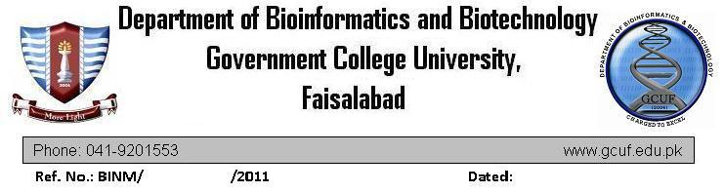  

One Day Symposium on “Prospects for A Glorious Pakistan: *Role of Emerging Technologies*” - December 12, 2013

**Registration Form**

Please complete a separate copy of this form for each registration. Payment in full must accompany the registration form.

|  |
| --- |
| Name: |
| Job Title: |
| Organization: |
| Tel: |
| Email: |

Mode of Payment:

|  |  |
| --- | --- |
| ☐Cash  ☐Bank Draft  ☐Online Transfer (Acc. No: PLS-1881-0; Branch code: 0308; The Bank of Punjab, GC University FSD. Title: Tahsin and Asma) | ☐Students **(Rs. 400/-)**  ☐Academia **(Rs. 800/-)**  ☐Industry **(Rs. 1200/-)** |

Signature: _______________ Date: _______________

------------------------------------------------------------------------------------------------------------

**Receipt**

|  |
| --- |
| Name: |
| Job Title: |
| Organization: |

Mode of Payment:

|  |  |
| --- | --- |
| ☐Cash  ☐Bank Draft  ☐Online Transfer (Acc. No: PLS-1881-0; Branch code: 0308; The Bank of Punjab, GC University FSD. Title: Tahsin and Asma) | ☐Students **(Rs. 400/-)**  ☐Academia **(Rs. 800/-)**  ☐Industry **(Rs. 1200/-)** |

Signature: _____________________ Date: _______________